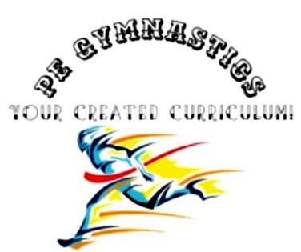
Title: squat
Type: clil, warming-up, bootcamp, fitness
Lesson Goal: learn the proper squat technique in 3 different ways

Instruction | Differentiation options | Extra info
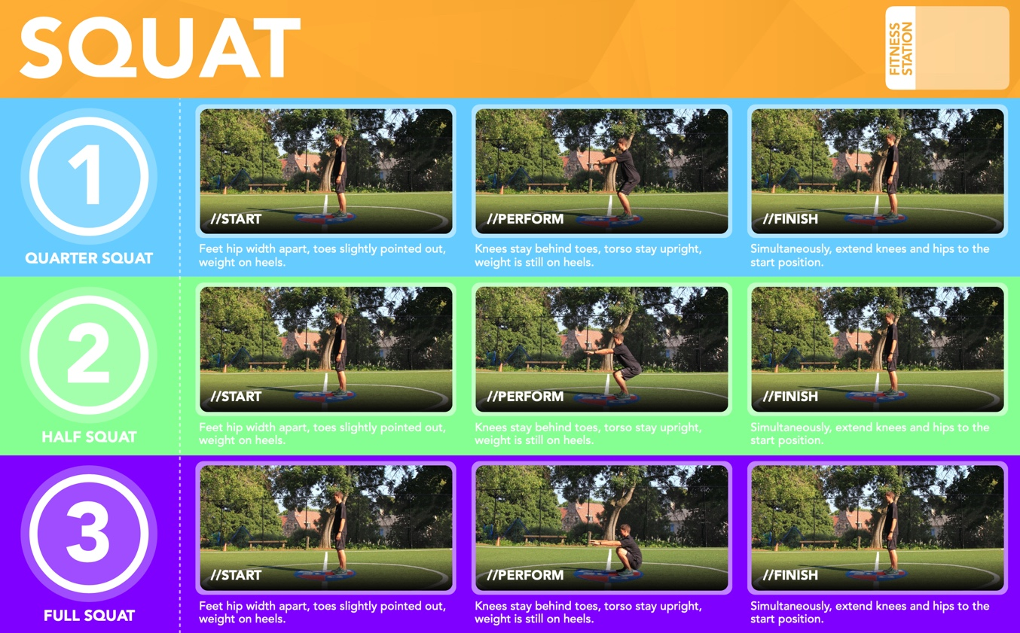
Field set-up:

Link to support/assessment document: www.thephysicaleducator.com

Additional pages if necessary:

