Musical Hoops

EQUIPMENT: hula hoops, music/whistle

PLAYING AREA: gymnasium or field
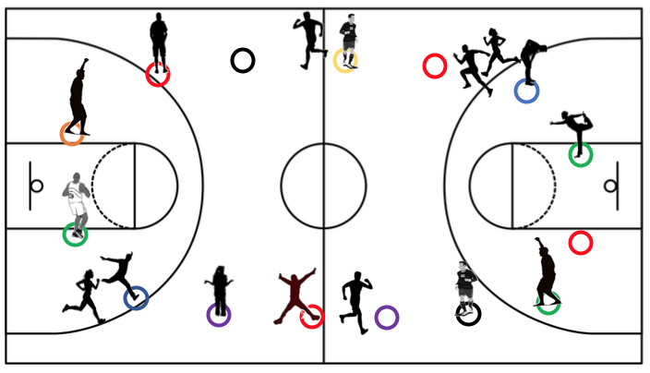

SET- UP:

- Set the hula hoops up in a circle.

- Set up the music or use another method, such as a whistle or verbal command to stop and start each round.

OBJECTIVE:

- The objective is to be the last person standing.

RULES:

- When the music starts, students run counter-clockwise around the circle.

- When the music stops, each student must find their own hula hoop to stand in. To get to a hula hoop, they must continue moving counter-clockwise around the outside of the circle.

- Whoever can’t find a hula hoop is eliminated. Students who are eliminated can help to be judges for the remaining rounds.

- If students double up in a hula hoop or make any kind of physical contact, they are both eliminated.

- Remove one hula hoop each round so there is always one more player than the number of hula hoops.

- The last person standing wins.

GAME VARIATIONS:

- Change the movement pattern to walking, skipping, or galloping.

- Students who are eliminated can do a fitness activity, such as 10 jumping jacks between each round.

Musical Hoops

