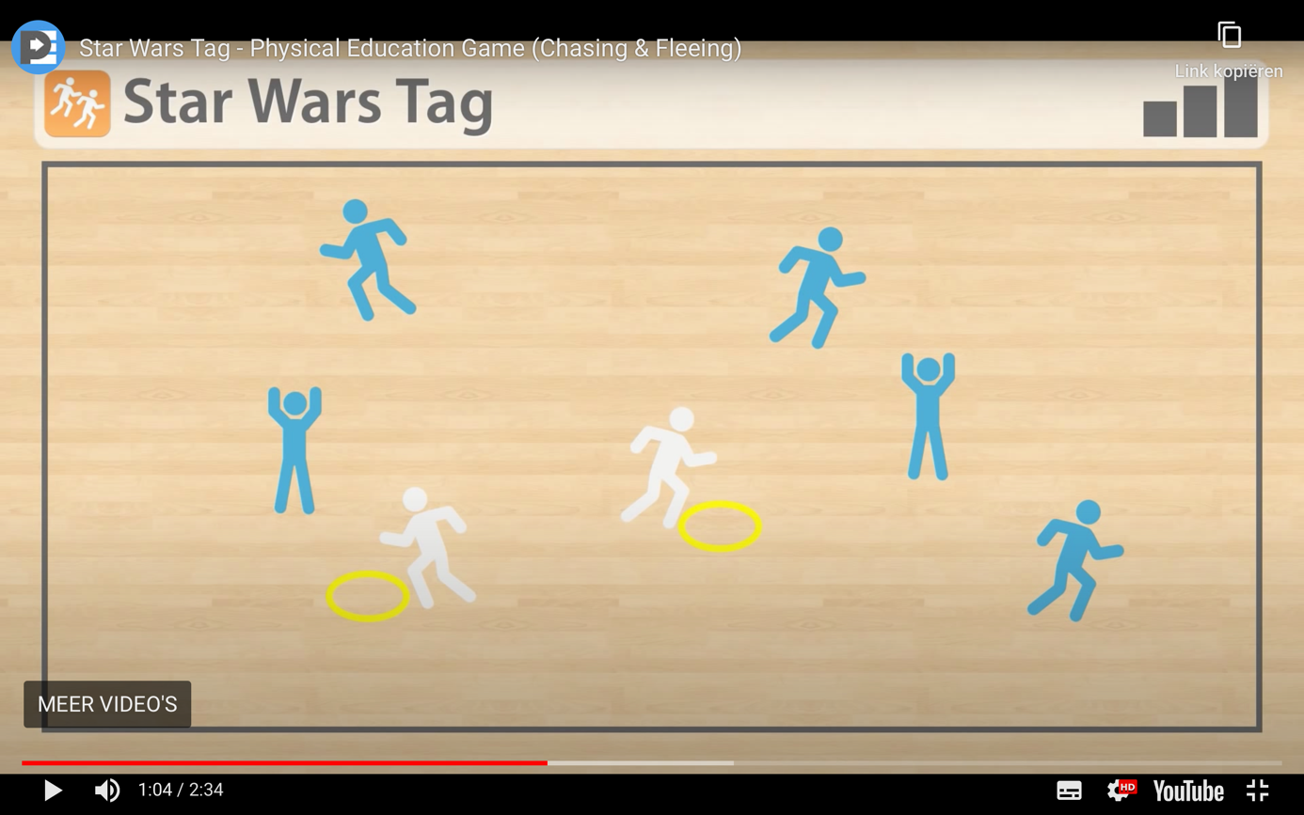

Star Wars Tag is always a huge hit with students in PE! It is a Standards-based Chasing and Fleeing game that is perfect for Elementary level students, but it can easily be adapted for Kindergarten programs and older students. It focuses on offensive and defensive strategies during gameplay, and can be played in your gym or outdoors.

Credits go to thephysicaleducator.com
Click at the link below to find the video including explanation:

https://thephysicaleducator.com/2012/10/30/halloween-games-for-physical-education/?ct=t(The_PhysEd_Newsletter_2_0_0022_4_2017_COPY_02)&mc_cid=668e81950a&mc_eid=d4a1622529

Quick Rules
Star Wars Tag is an exciting game that your students are sure to love.
Just like any great story, the game is broken down into chapters with each chapter introducing a new character to the action.
Use the builds below to help you build this game up, layer by layer.
Feel free to add your own characters with their own powers in any additional builds!

Builds
Build One: The Rebels
Students get into a scattered formation in the playing area.
All students begin the game as Rebels.
On the teacher’s signal, the Rebels explore this star system by running around while avoiding contact with other Rebels.

Build Two: Stormtroopers
Upon hearing about all of the Rebel activity in this star system, the Empire decides to send in a squadron of Stormtroopers to deal with the problem.
Select 2-3 students to be Stormtroopers.
Stormtroopers wear white uniforms (pinnies) and are given yellow Blasters (hula hoops).
Stormtroopers attempt to tag Rebels by kicking their blaster (hula hoop) so that it slides on the ground and makes contact with a Rebel’s feet.
If a Rebel is tagged, they become frozen in place (well… carbonite)
Build Three: Rebel Leaders
After getting word that the Rebel fleet is under attack, the Rebel Alliance sends in two of their greatest leaders: Luke Skywalker and General Leia Organa.
Select two students to be Luke and Leia. Give each of them a Lightsaber (foamie).
Luke and Leia attempt to free frozen Rebels by tapping them with their Lightsabers.
Being Rebels themselves, Luke and Leia must avoid being tagged by the Stormtroopers. If tagged, they become frozen. However, Leia may unfreeze Luke and vice-versa.
Build Four: Darth Vader
Hearing that Luke and Leia have joined the battle, the Empire sends in their most feared leader: Darth Vader.
Select one student to be Darth Vader. Darth Vader must wear a black pinnie and is given a red Blaster (hula hoop).
Just like the Stormtroopers, Darth Vader attempts to tag Rebels with his Blaster. However, if a Rebel is tagged with Vader’s red Blaster, they must get a white pinnie and yellow blaster and rejoin the game as a Stormtrooper. Therefore, there will be more and more Stormtroopers in the game.
If Luke or Leia are tagged by Vader, they must drop their Lightsaber and rejoin the game as a Stormtrooper. Any Rebel may take on the Luke or Leia role by picking up the dropped Lightsaber.
Build Five: Return of the Jedi
Having felt a great disturbance in the Force, Master Yoda decides to join the battle.
Select one student to play the role of Yoda. Yoda must wear a green pinnie and is given a green blaster.
Yoda plays the same role as Darth Vader, except that he targets Stormtroopers. If a Stormtrooper is tagged by Yoda’s blaster, that Stormtrooper must put away their uniform and Blaster and rejoin the game as a Rebel.
Being masters of the Force, Yoda and Vader are immune to all Blaster attacks (including each others).

Grade Level Outcomes
Applies simple offensive strategies/ tactics in chasing and fleeing activities. (S2.E5.4a)
Applies simple defensive strategies/ tactics in chasing and fleeing activities. (S2.E5.4b)

Discussion Questions
How do you successfully avoid being tagged in this game?
How do you successfully tag other players?
What information do you use in this game to help guide your decisions and actions?

Safety Information
Tags must keep their hoops on the ground and only kick a hoop if it is flat on the ground.
Runners should avoid stepping on hoops to prevent sliding.

Equipment Requirements
Pinnies (white, black, green)
Hula Hoops (yellow, red, green)
Foamies

