
Title: Game category poster
Type: CLIL, games
Lesson Goal: Understand the different categories of games

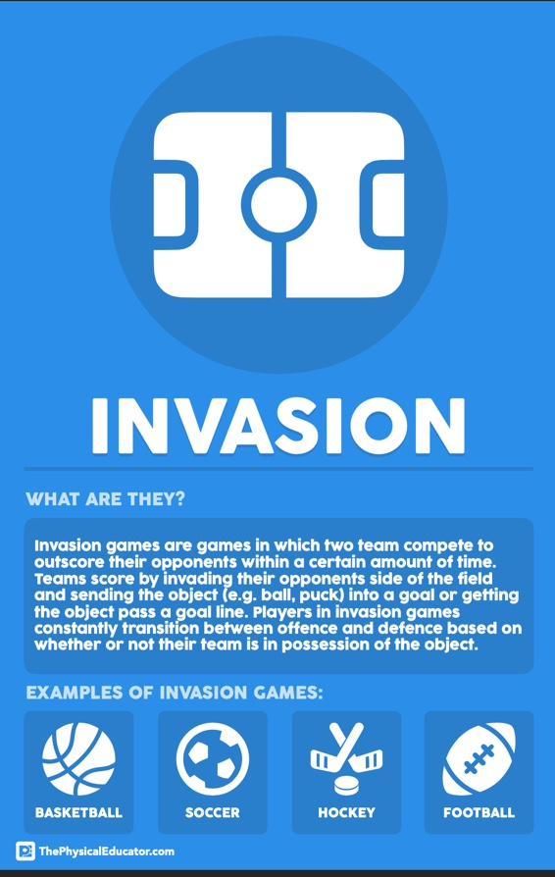
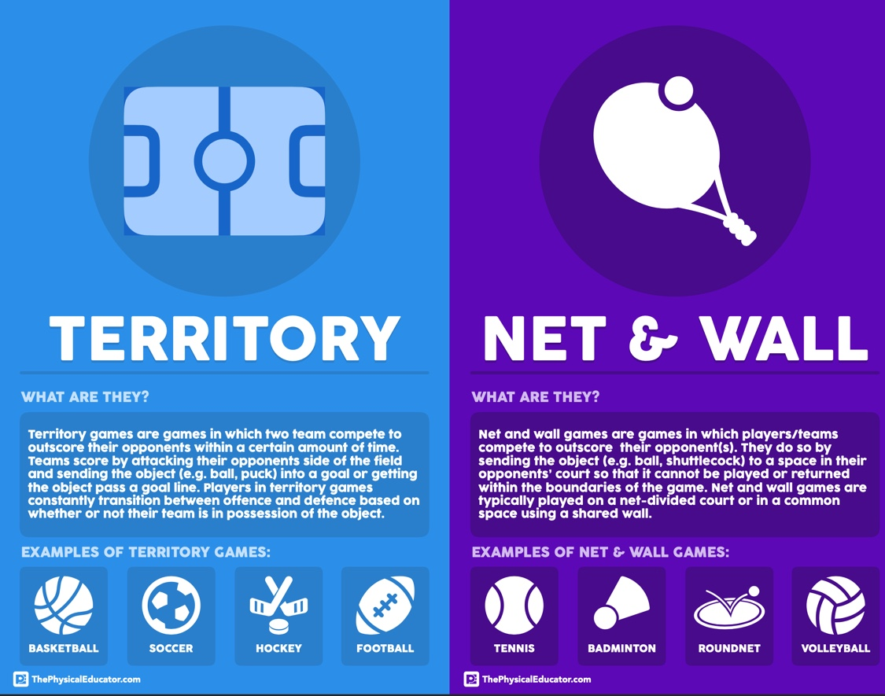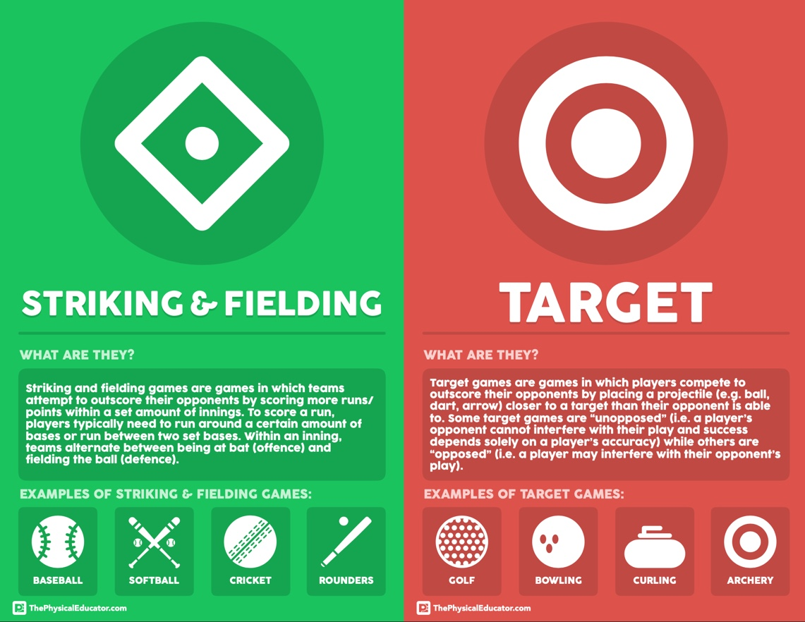
Instruction | Differentiation options | Extra info
ThePhysicalEducator.com

Product: Game Category Posters
==================================
Version 1.0
Created by: ThePhysicalEducator.com
Creation year: 2019
Copyright (c) 2010-2019 ThePhysicalEducator.com
Source URL: http://www.thephysicaleducator.com/shop

================
I created the Game Category Posters to help my middle school students make sense of the different categories of games we explore in class:

1. Target Games
2. Striking and Fielding Games
3. Net and Wall Games
4. Invasion/Territory Games

Along with a game category icon and description, I also include four examples of games that fall within each category so that students could quickly reflect on other possible games with the category

I hope you enjoy these posters and that – at the very least – they bring some fun colours into your gym!

Happy Teaching!

================
LICENSE:
Instead of some fancy legal talk, here’s what you should know in plain English:
- This item (or any of its parts) may not be resold. You can use it in your teaching and include it in your presentations, but do not sell it as part of any product you sell without my written consent.
- This item cannot be used on merchandise for sell. I know it looks nice, but you can’t make it into a T shirt.
- This item cannot be used as a logo for your brand, site, store, etc.

================

Field set-up:

Link to support/assessment document: www.thephysicaleducator.com

