**KICKBACK SOCCER**

**EQUIPMENT:** 16 pylons, 4 beanbags, 2 or 3 soccer balls

**PLAYING AREA:** field

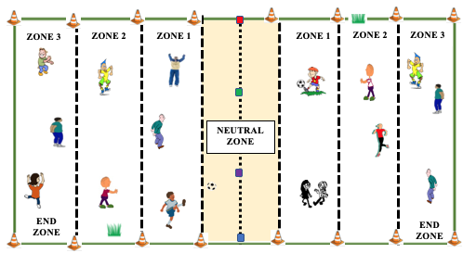

**SET-UP:**

* Set up pylons to mark off the perimeter of the field, three zones on each side of the field, and a neutral zone in the middle. Mark off the center of the neutral zone with beanbags.
* Break the class into two teams. Then divide the students, as evenly as possible, into three zones for each team.
* Give each team a soccer ball.

**OBJECTIVE:** The objective is to kick a soccer ball through your opponents’ end zone.

**RULES:**

* Players can move back and forth within their zone but can’t leave their zone except to retrieve a ball that’s out of play. If a player leaves their zone to play a ball, the other team gets the ball on their own side of the neutral zone.
* Players kick the ball from their zone as far as they can to their opponents’ side.
* Players on the receiving team try to trap the ball as it passes through their zone.
* From the spot where they trapped the ball, players return the kick to their opponents’ side of the field.
* If the ball doesn’t make it to the other side, or stops in the neutral zone, the receiving team kicks the ball from their side of the neutral zone.
* If the ball is kicked or deflected out of bounds, the receiving team kicks it back from the zone where it went out.
* If the ball deflects off a receiving player, it’s played from where it comes to rest. If it deflects out of bounds, the kicking team gets the ball on their side of the neutral zone.
* No hands allowed! If a player touches the ball with their hands, the other team scores a point and gets a free kick from their side of the neutral zone.
* Teams score a point if their kicked ball passes completely through their opponents’ end zone.
* Play is continuous with both/all of the soccer balls in play at all times.
* Players rotate zones periodically throughout the game.

**GAME VARIATIONS**:

* Add another soccer ball to the game.
* If there are fewer players, only use two zones instead of three on each side of the field.

**Kickback**