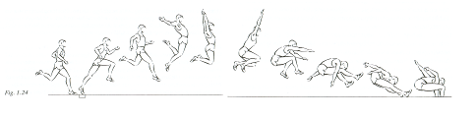

|  |  |
| --- | --- |
| **Assessment Form**  - **Long-Jump** | |
| *1. Start-up phase- Climaxstart-up(long distance)* | *2.Start-up phase- Sprintstart-up(short distance)* |
| * Measuring the steps * Building up the run * Use the arms to support your run * Straight line | * Measuring the steps * Excellerate through the whole run * Use the arms to support your run * Straight line |
| 2. Take-off phase |  |
| * Take-off point/spot:   *Center of gravity(COG) above your hips  *Take-off using flat feet   * Stretching out the leg you push off with:   *Extend fast to gain more speed   * Supporting your take-off:   *Support the arms and the leg you reach with to extend the jump  *Moving the knee up/forwards   * Forward speed after take-off:   *COG is behind the leg you push off with , | |
| 3. Gliding phase |  |
| * Squat technique:   *Extend the upperbody  *Pull in both legs AFTER take-off  *Control the jump with the arms |  |
| 4. Landing phase |  |
| * Landing the squat technique:   *Both legs extend forward  *Legs bend when they touch the sand  *Hips are pushed forward  *Arms extend forward whil landing |  |

**ATTENTION**: *This assignment can only be used after a few lessons of long-jumping.*

**Long-jump - Assignment using 3 students**

-Each group will be given an assessment form – Long jump

-The teacher will give 4 groups a different phase to explain in front of the class, using examples and explain the keywords. ( 2 minutes)

-Students will present there given phase and students/teacher can ask questions.

-When the four phases are presented the groups will split up amongst the four long-jump area’s and will start their **warm-up*.** After the warm-up every student of each group will measure there steps.

-Example 1 - Organisation: student 1 is jumping , student 2 will give feedback(start with phase 1/ 2 ) , student 3 will pay attention to phase 3 / 4 ). After a few rounds students rotate.

--------------------------------------------------------------------------------------------------------------------------------------

**There are different organisations that can be used:**

**-Group size(every student has there own phase to look at).**

**-Working in pairs**

**Etc.**