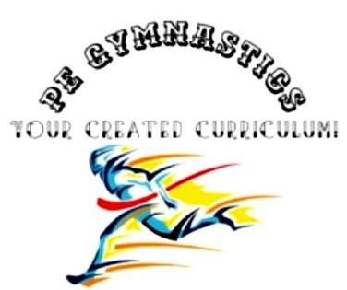
Title: Crunch
Type: Clil, crunch, warming-up, bootcamp
Lesson Goal: Learn the proper technique of the Crunch

Instruction | Differentiation options | Extra info
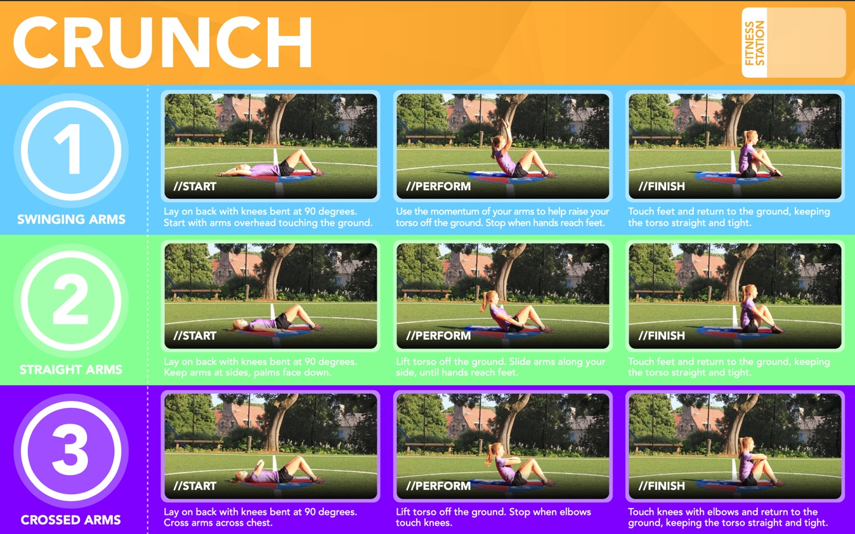
Field set-up:

Link to support/assessment document: www.thephysicaleducator.com

Additional pages if necessary:

