Beanbag Pentathlon

EQUIPMENT: beanbags (one per student), 8 pylons, 4 hula hoops, beanbag station posters, student record sheets, pencils, stopwatch

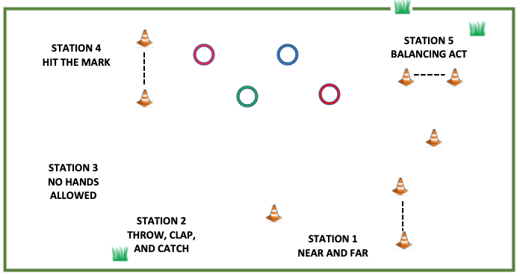

PLAYING AREA: field

SET-UP:

- Set up 5 stations as shown above. Put the proper station poster at each location.

- Divide the class into 5 groups. Have each group start at a different station.

OBJECTIVE:

- The objective is participate in different beanbag activities to score points at each station and accumulate as many points as possible.
RULES:

- You will be allowed 5 minutes at each station to accumulate as many points as possible. Posters at each station will give you directions on how to earn points.

The stations are:

- Near and Far – Throw your beanbag as far as possible using different motions.
- Throw, Clap, and Catch – Throw your beanbag in the air. Then clap as many times as you can before catching it.
- No Hands Allowed – Keep your beanbag in the air for as many touches as possible. Touches include having the beanbag hit any part of your body except your hands.
- Hit the Mark: Collect points by throwing your beanbag from different distance and landing it completely in a hula hoop.
- Balancing Act: Balance your beanbag in different ways while moving around a pylon.

- Between stations, you will be allowed about a minute to record your score, move to the next station, and read the rules for that station.

- Don’t touch other players’ beanbags.

- Don’t touch other players.

GAME VARIATIONS:

- Lengthen or shorten the distances for Stations 1, 4, and 5. The distances aren’t given for these activities because they will vary considerably for each grade level. Choose distances that are achievable for some of your students but not overwhelming for others.

Beanbag Pentathlon

STATION 1
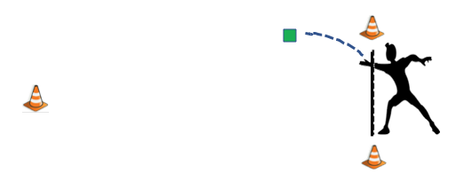
NEAR AND FAR

RULES

- Start behind the pylon line. You will earn 2 points for each type of throw that completely passes each marker. If you finish early, you can earn 1 bonus point if you can successfully complete all of the throws a second time.

Types of Throws

- overhand throw with dominant hand: If you are right-handed, throw the beanbag overhand with your right hand.

- overhand throw with non-dominant hand: If you are right-handed, throw the beanbag overhand with your left hand.

- underhand throw with dominant hand: If you are right-handed, throw the beanbag underhand with your right hand.

- underhand throw with non-dominant hand: If you are right-handed, throw the beanbag underhand with your left hand.

- football type hike: Hike the beanbag through your legs like a football player would hike the ball to the quarterback.

STATION 2
THROW, CLAP, AND CATCH

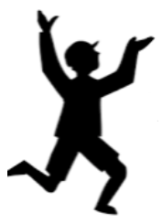

RULES

- Throw your beanbag as high you can.

- While it’s in the air clap as many times as you can and count your claps.

- Catch your beanbag when it comes down.

- You can only score points on any throw if you catch the beanbag.

- Only count your highest score. Each clap is worth one point.

STATION 3
NO HANDS ALLOWED

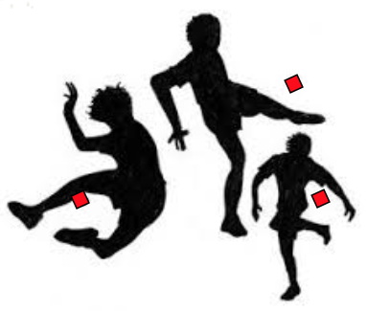

RULES

- You can use your hands to get your beanbag in the air. After that, you’re not allowed to use your hands.

- Keep your beanbag in the air for as many touches as possible. Touches include having a beanbag hit any part of your body except your hands.

- If your beanbag touches the ground, start counting again.

- Only count your highest score.

STATION 4
HIT THE MARK

RULES
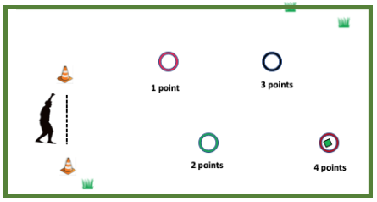

- Start behind the pylon line.

- Using any type of throwing motion, try to land your beanbag completely inside a hula hoop. The closest hoop is worth one point, the next is worth 2 points, and so on until the farthest hoop, which is worth 4 points.

- You must successfully complete each level from 1 to 4 before moving on to the next level.

- If you finish early, you can earn 1 bonus point if you can successfully complete all of the throws a second time.
STATION 5
BALANCING ACT

RULES
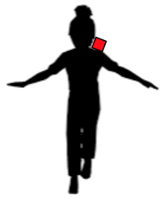
- Start behind the pylon line You will earn 1 point each time you walk around a pylon and back again while balancing a beanbag on your body.

- If the beanbag drops before you get back to the line, then pick it up and start that level again.

- You must complete each level before moving on to the next level. The levels get progressively more difficult. The following are the body parts you must balance the beanbag on:

Level 1: in the palm of your hand
Level 2: on the back of your hand
Level 3: on one finger
Level 4: on your elbow
Level 5: on your head
Level 6: on your shoulder
Level 7: on your back
Level 8: on the back of your neck
Level 9: on your tummy
Level 10: between your knees

BEANBAG PENTATHLON STUDENT RECORD SHEET

Name: ___________________________ * possible points are in brackets

STATION 1: NEAR AND FAR
  - overhand with dominant hand (2) ____
  - overhand with non-dominant hand (2) ____
  - underhand with dominant hand (2) ____
  - underhand with non-dominant hand (2) ____
  - hiking football style (2) ____
  - bonus (1) ____
STATION 2: THROW, CLAP, AND CATCH
- best score – most claps on one throw (no max) ____

STATION 3: NO HANDS ALLOWED
- best score – highest number of touches (no max) ____

STATION 4: HIT THE MARK
- 1st hoop (1) ____
- 2nd hoop (2) ____
- 3rd hoop (3) ____
- 4th hoop (4) ____
- bonus (1) ____

STATION 1: BALANCING ACT
- Level 1: on palm of hand (1) ____
- Level 2: on back of hand (1) ____
- Level 3: on one finger (1) ____
- Level 4: on your elbow (1) ____
- Level 5: on your head (1) ____
- Level 6: on your shoulder (1) ____
- Level 7: on your back (1) ____
- Level 8: on the back of your neck (1) ____
- Level 9: on your tummy (1) ____
- Level 10: between your knees (1) ____
GRAND TOTAL ____

