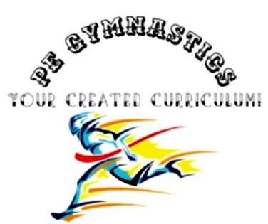
Title: Burpee
Type: Clil, Burpee, warming-up, athletics
Lesson Goal: Learn the proper technique of a burpee.

Instruction | Differentiation options | Extra info
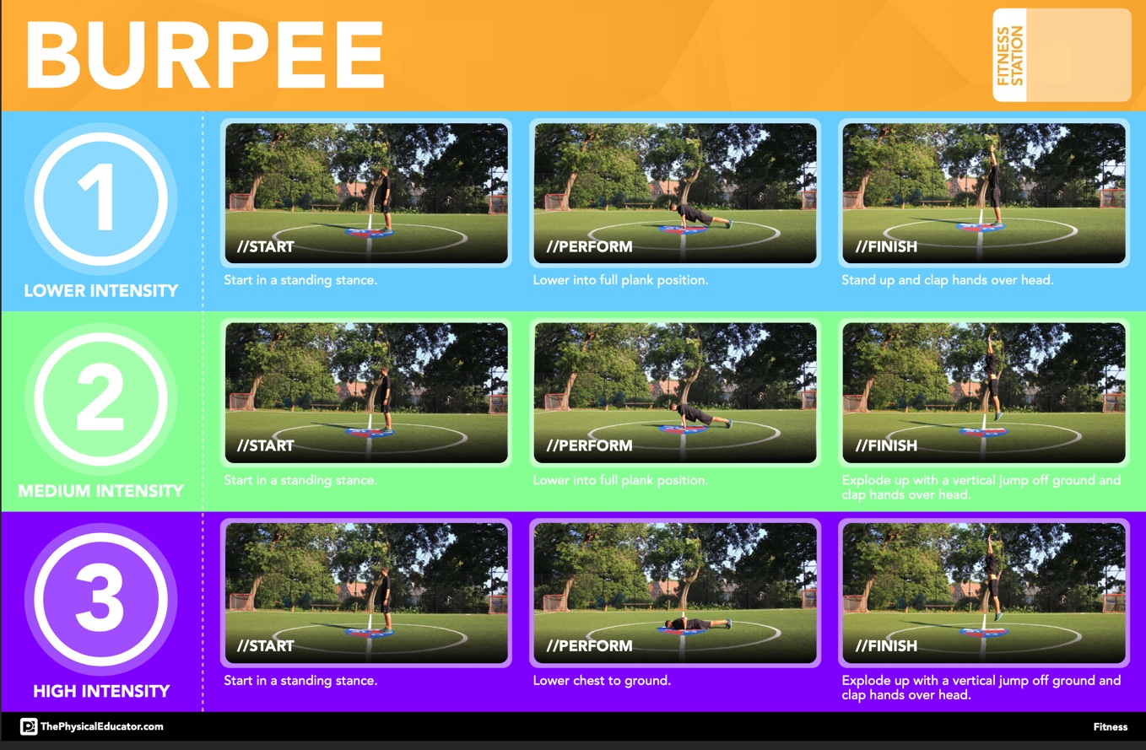
Field set-up:

Link to support/assessment document: www.thephysiscaleducator.com

Additional pages if necessary:

