
Title: Listen with your body
Type: CLIL
Lesson Goal: Coach tips, general

Instruction | Extra info
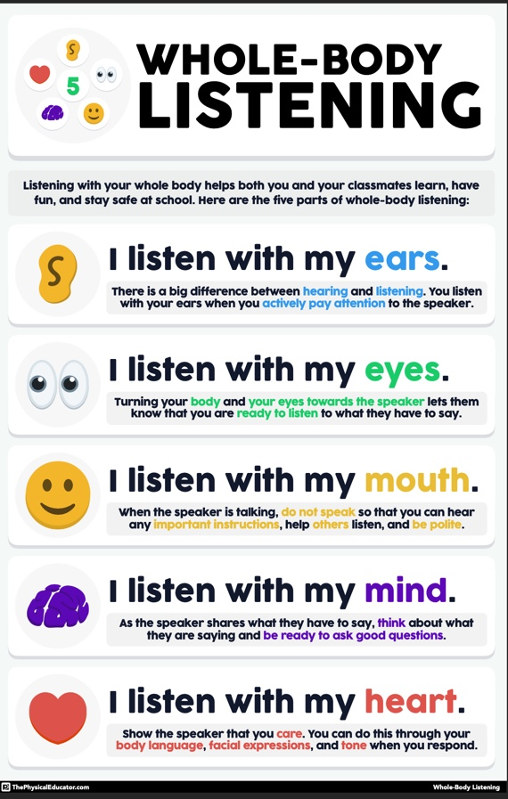
Field set-up:

Link to support/assessment document: www.the physicaleducator.com

Additional pages if necessary:

