Rock, Paper, Scissors Dribble Challenge

EQUIPMENT: 8 pylons and 4 soccer balls for each game

PLAYING AREA: field

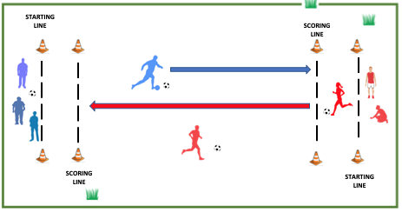

SET-UP:

- Set up pylons as shown in the diagram. The scoring line should be about 6 feet in front of the starting line on each end.

- Divide the class into teams of about four on each team. The diagram above shows a game between two teams, red and blue, but several games could be set up to involve more students. Give two soccer balls to each team.

OBJECTIVES:

- The objective is to score as many points as possible by dribbling your soccer ball past your opponents’ scoring line. Along the way, you will have rock, paper, scissors battles.
RULES:

- On “Go”, a member from each team will dribble a soccer ball as quickly as possible toward their opponents’ scoring line.

- The ball must be dribbled, not kicked ahead and chased.

- When the opponents meet, they will have a rock, paper, scissors battle. Rock beats scissors. Scissors beats paper. Paper beats rock.

- As soon as the battle ends, the winner keeps dribbling towards the other team’s scoring line and the losing player moves to the side of the field, then kicks or dribbles the ball back towards their own end.

- At the same time, a new member from the losing team dribbles out to meet the opponent who is advancing towards their end. When they meet, they will have a rock, paper, scissors battle, and then they will continue the game.

- Players who are next in line need to be ready and react as quickly as soon as a battle is complete.

- Teams score a point every time they dribble a ball over their opponents’ scoring line.

- After each point is scored, the teams go back to their staring positions and play again.

GAME VARIATIONS:

- The game can last for a designated period of time or until a team scores a predetermined number of points.

- The number of players on each team can be changed.

- The distance between scoring lines can be changed.

Rock, Paper, Scissors Dribble Challenge

