ENDURANCE RUN

Learning goals You are able to:
- Keep running for 8 minutes;
- 8 minutes running = 5,5
For girls 1300 meters + continuous running = 5,5
Boys 1350 meters + continuous running = 5,5;
- Single handedly divide your tempo so you can cover the most distance;
- Measure your heart rate in two ways;
- Making a running schedule so the coach can keep track of your lap time and can stimulate you to walk faster and give you information whether you are on schedule;
- Coach your partner with the help of your schedule.

Important points You are able to:
- Girls 1300 meters + continuous running = 5,5;
Boys 1350 meter + continuous running = 5,5.

The test In the lesson:
- Running laps around the school or laps on the field behind the school;
- Coach is in one point watching the lap times and reporting that to the teacher.

THE HEART RATE

As you may have noticed, your heart beats faster when you are busy. It may be because you had to run n order to cathc a bus or because you happen to be in a fight with a friend. In both cases your heart rate will be up and you can feel that without having to perform any action.

We like to talk about the heart rate during movement. Because when you move your heart beats faster. The number of beats is called the heart rate. This heart rate is very important if you want to improve your stamina or if you want to lose weight. In a number of weeks you get a running test of 8 minutes. In practicing for this test it is important to know how you can iprove your stamina. Imagine you have a test of 8 minutes of running ina couple of weeks and you are going to practice really hard to get a good grade. Three times a week you work up a sweat. In the test it appears that you score four out of ten. You wander how that is possible. That is because your maximum heart rate per minute is average 220 minus your age. In order to train stamina your rate must be between 160 and 180 otherwise you do not train stamina. If you are above 180 you will experience muscle aches (during and especially after sports). Ifyou are below that you do not train stamina and it is a waste of time.

Rules for improving the stamina:

The heart rate between 160 and 180 per minute

How doe I measure my heart rate?


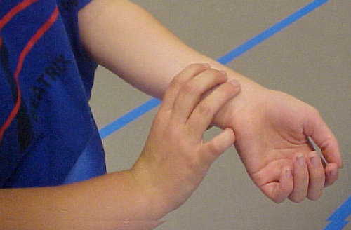

In order to help you, you can use the schedule on the next page. Try to stick to the schedule and you will see that you will do fine on the test. You can of course practice in a different way or not at all.

A schedule for training

Week one
2 times running and two days of rest
- 2 minutes running at a good heart rate, 1 minute walking and measuring the heart rate. Repeat this three times.

Week two
3 times running with one and two days rest
- The fist day 3 minutes running, 1,5 minutes walking and measuring heart rate.
Repeat three times.
- The second day three minutes running, one minute walking and measuring the heart rate.
Repeat three times.
- De derde dag 3 minuten rennen, 1 minuut rustig uitwandelen en HF opmeten
Totaal drie maal herhalen.

Week three
2 times running 3 days rest
- The first day five minute running, 2 minutes walking and measuring heart rate.
Repeat two times.
- The second day 9 minutes running in one go, afterwards walk and measure heart rate.

Remark: If you measure your heart rate it hs to be between 160-180. If it is not you have to run either faster or slower in order to get to this heart rate!

8 MINUTE endurance run assignment

- De test is outside, We walk on the field.
- 1 lap is 250 meters.
- In this lesson you work in pairs. One is the coach and one is the runner. Each one is runner and coach in turns.
- As a runner you have to goal to run for 8 minutes and to run as for as possible. The coach will write the lap times on the form and will encourage the runner.
- After all has been filled out the runner knows whether he/she has to work run faster or can slow down. The lap times give a lot of useful information. Did you feel good in the first laps and lost a lot of time in the last ones. You can take all that informaiton into account.

The practice lesson:
The coach takes record of the lap times and encourages the runner.
The runner runs as fast as possible.

Homework:
Take the laptimes and think about your run. Fill out the lap times you want to run in the test lesson.Spread your powers during the eight minutes!

My coach for the lesson and test lesson is:____________________________

Field

 | distance | Lap times during the practice lesson  Name: | During the test I will make these lap times | Lap times test lessons  Name:
1. | 250
2. | 500
3. | 750
4. | 1000
5. | 1250
6. | 1500
7. | 1750
Total distance

Criteria

Lap =  250 m | Distance | Grade girls | Grade boys
4 | 1000 | 2,5 | 2
4 + 50 m | 1050 | 3 | 2,5
4 + 100 m | 1100 | 3,5 | 3
4 + 150 m | 1150 | 4 | 3,5
4 + 200 m | 1200 | 4,5 | 4
5 | 1250 | 5 | 4,5
5 + 50 m | 1300 | 5,5 | 5
5 + 100 m | 1350 | 6 | 5,5
5 + 150 m | 1400 | 6,5 | 6
5 + 200 m | 1450 | 7 | 6,5
6 | 1500 | 7,5 | 7
6 + 50 m | 1550 | 8 | 7,5
6 + 100 m | 1600 | 8,5 | 8
6 + 150 m | 1650 | 9 | 8,5
6 + 200 m | 1700 | 9,5 | 9
7 | 1750 | 10 | 9,5
7 + 50 m | 1800 |  | 10

GRADE

