Healthy Hearts

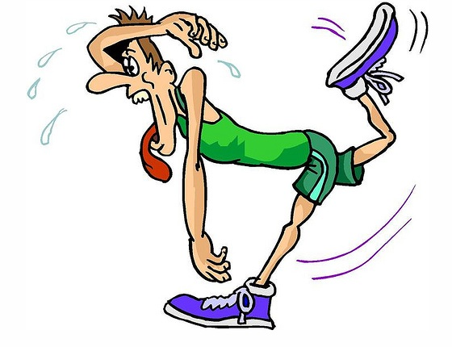

[](http://www.google.co.uk/imgres?q=cartoon+run&um=1&hl=en&tbo=d&biw=1364&bih=587&tbm=isch&tbnid=K3PhfLA2AOV73M:&imgrefurl=http://www.how-to-draw-funny-cartoons.com/cartoon-running.html&docid=qBJULjgg23UeaM&imgurl=http://www.how-to-draw-funny-cartoons.com/image-files/cartoon-running-6.gif&w=450&h=450&ei=5CC1UI66EK3T4QTFsIH4Bw&zoom=1&iact=hc&vpx=637&vpy=155&dur=3281&hovh=225&hovw=225&tx=118&ty=101&sig=109459491734992003076&page=1&tbnh=108&tbnw=110&start=0&ndsp=30&ved=1t:429,r:5,s:0,i:168)

[](http://www.google.co.uk/imgres?q=cartoon+sit+ups&um=1&hl=en&tbo=d&biw=1364&bih=587&tbm=isch&tbnid=GQz-QuaeJNokCM:&imgrefurl=http://www.istockphoto.com/stock-illustration-11485705-sit-ups.php&docid=s1SLiXqxsVfyOM&imgurl=http://i.istockimg.com/file_thumbview_approve/11485705/2/stock-illustration-11485705-sit-ups.jpg&w=380&h=285&ei=xR-1UOO5F-TS4QS5soDgBw&zoom=1&iact=hc&vpx=2&vpy=171&dur=2125&hovh=194&hovw=259&tx=162&ty=129&sig=109459491734992003076&page=1&tbnh=109&tbnw=145&start=0&ndsp=29&ved=1t:429,r:0,s:0,i:127)

[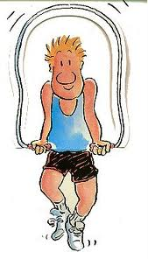](http://www.google.co.uk/imgres?q=cartoon+skipping&um=1&hl=en&tbo=d&biw=1364&bih=587&tbm=isch&tbnid=ltmP4Y6ZdlPg8M:&imgrefurl=http://blog.luckyvitamin.com/category/mens-health/&docid=R1eKsFcJi1kQtM&imgurl=http://blog.luckyvitamin.com/wp-content/uploads/2009/05/jump-cartoon.jpg&w=212&h=370&ei=9R61UO66LI_a4QTH4YDICA&zoom=1&iact=hc&vpx=389&vpy=157&dur=2188&hovh=296&hovw=169&tx=90&ty=200&sig=109459491734992003076&page=1&tbnh=113&tbnw=65&start=0&ndsp=34&ved=1t:429,r:15,s:0,i:199)

Pupil Record Card

Name _______________________________ Class _____________

|  |  |  |  |  |  |  |  |  |
| --- | --- | --- | --- | --- | --- | --- | --- | --- |
| Date |  |  |  |  |  |  |  |  |
| 1. Speed Bounce |  |  |  |  |  |  |  |  |
| 1. Step Ups |  |  |  |  |  |  |  |  |
| 1. Ball Catch |  |  |  |  |  |  |  |  |
| 1. Skipping |  |  |  |  |  |  |  |  |
| 1. Star Jumps |  |  |  |  |  |  |  |  |
| 1. Throw 4 Accuracy |  |  |  |  |  |  |  |  |
| 1. Sit Ups |  |  |  |  |  |  |  |  |
| 1. Shuttle Run |  |  |  |  |  |  |  |  |
| 1. Spotty Dog |  |  |  |  |  |  |  |  |
| **Total Score** |  |  |  |  |  |  |  |  |



[](http://www.google.co.uk/imgres?q=cartoon+strong&um=1&hl=en&tbo=d&biw=1364&bih=587&tbm=isch&tbnid=YyWATXmXoIU7eM:&imgrefurl=http://www.mrmenshowblog.com/mr_men_show_blog/2007/10/a-new-friend.html&docid=qtasd9G54FM2SM&imgurl=http://www.mrmenshowblog.com/photos/uncategorized/2007/10/02/mrstrongms2809_468x359.jpg&w=468&h=359&ei=IyK1UJH0L5DV4QTUy4GoDA&zoom=1&iact=hc&vpx=592&vpy=255&dur=5281&hovh=197&hovw=256&tx=159&ty=80&sig=109459491734992003076&page=1&tbnh=111&tbnw=145&start=0&ndsp=33&ved=1t:429,r:27,s:0,i:184)

[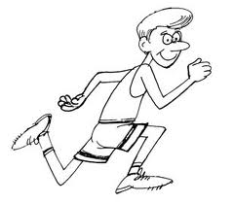](http://www.google.co.uk/imgres?q=cartoon+runner&um=1&hl=en&tbo=d&biw=1364&bih=587&tbm=isch&tbnid=dWRAtkGTS8o-iM:&imgrefurl=http://centralnassau.org/annual-5k-runday/runner-cartoon/&docid=xoPS0y37ZjlekM&imgurl=http://centralnassau.org/wp-content/uploads/2012/05/Runner-Cartoon.jpg&w=309&h=271&ei=Uh-1UPLpA6Pk4QS2nYCYCQ&zoom=1&iact=hc&vpx=76&vpy=156&dur=2015&hovh=210&hovw=240&tx=144&ty=120&sig=109459491734992003076&page=1&tbnh=106&tbnw=123&start=0&ndsp=33&ved=1t:429,r:1,s:0,i:156)