**Title: Wellness poster**   
  
**Type: clil, general, PIF**  
  
**Lesson Goal:** **Extra info about which words you can use to reflect about your wellness**

**created the Dimensions of Wellness Poster & Reflection Booklet as part of a staff wellness presentation at my school. The idea was to help my school’s faculty and staff learn about the dimensions of wellness, reflect on how they are doing in regards to each dimension, and then share successes or questions they may have in regards to thriving in certain dimensions.**

**Learn more about my presentation and how I used the reflection booklet in this blog post: https://thephysicaleducator.com/2019/02/17/dimensions-of-wellness/**

**The reflection booklet can be folded from a single piece of paper and only requires one cut. You can see how to fold your reflection booklet in this video: https://youtu.be/TUrALTBP3gE**

**Happy Teaching!**

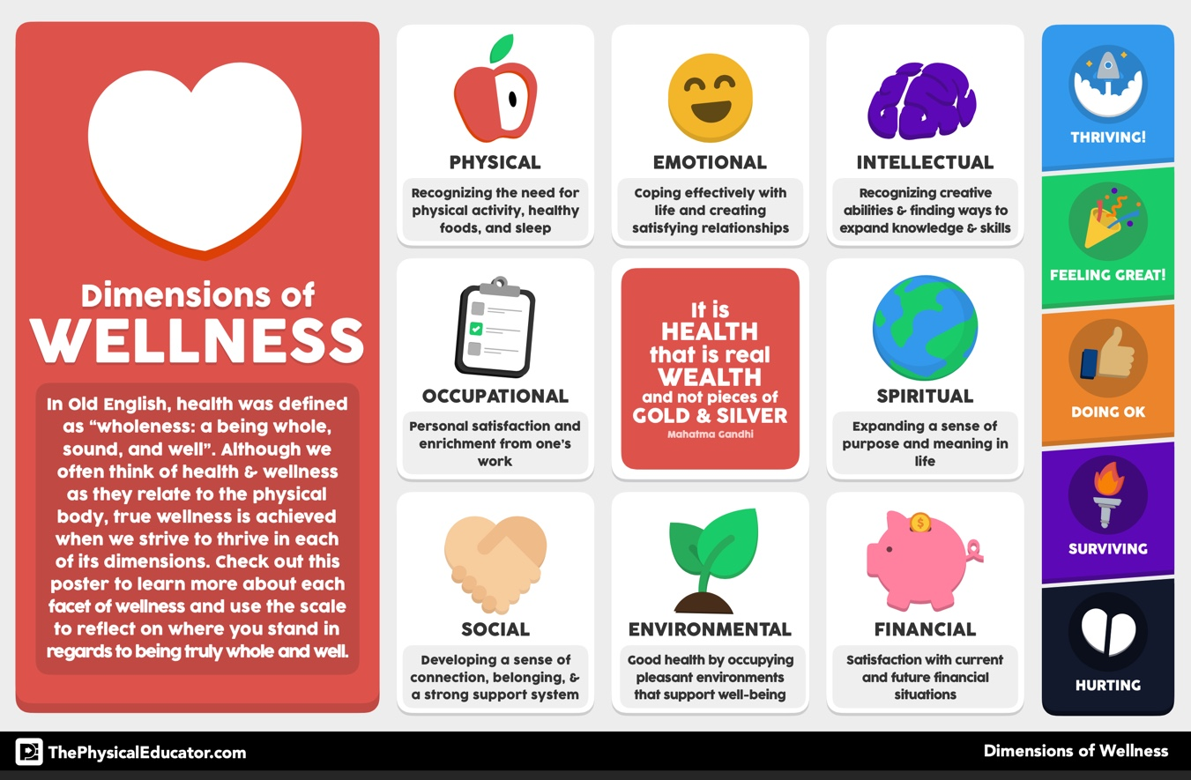

**Additional pages if necessary:** [**www.thephysicaleducator.com**](http://www.thephysicaleducator.com)