Frisbee Golf

EQUIPMENT: frisbees (one per student), 9 pylons (one per hole), 9 skipping ropes (one per hole), scorecards, pencils

PLAYING AREA: field
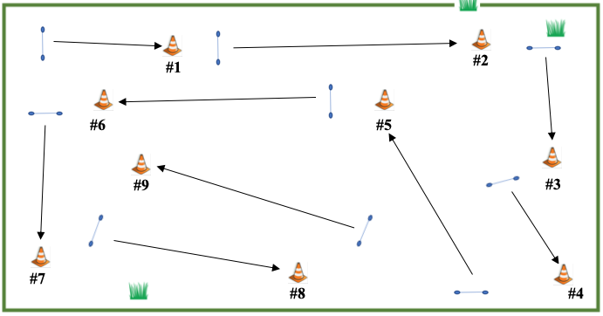

SET-UP:

- Set up a 9-hole golf course. The skipping rope is the tee box. The pylons are the holes.

- Hand out scorecards and pencils.

- Assign students to different starting holes for a shotgun start. Depending on numbers, they can be put into groups of 2 or 3, but each golfer should record their own score.

OBJECTIVE:

- The objective is to hit the pylon on each hole with your Frisbee in the fewest number of strokes.

RULES:

- The only thing you’re allowed to touch is your own Frisbee, and you should sanitize it after your round of golf is finished.

- Start behind the skipping rope on each hole and toss your Frisbee at the pylon. If you hit it, you’re finished the hole. If not, pick it up wherever it lands and keep tossing until you hit the pylon.

- Each toss is one stroke.

GAME VARIATIONS:

- Extend the course to make an 18-hole course.

- Play match play golf, where players try to win each hole, but their overall score doesn’t matter. If players tie on a hole, they each get a half point.

- Set up dog-leg holes so students need to throw around obstacles such as playground equipment.

- Vary the lengths of the holes and assign a par for each hole.

- Students can set up their own holes by deciding beforehand where the hole will be. For example, it could be a tree, teeter-totter, or rock.

Frisbee Golf
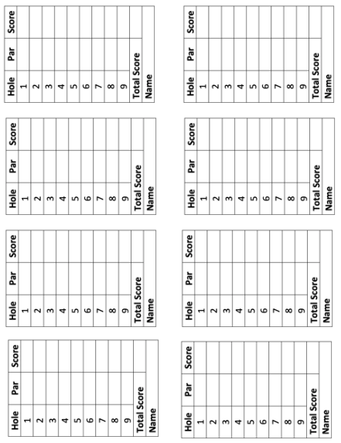
Frisbee Golf Scorecards

