Observe someone else long jumping and use the following points to try and improve his / her technique.

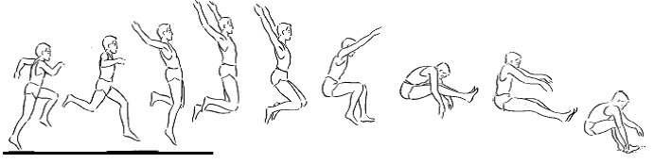

APPROACH
- Start the approach by stepping onto your takeoff foot
- Mark the run up out using a cone or flag
- Good, fast sprinting technique lifting the knees high
- Run fast but not too fast that you can not control your jump

TAKEOFF
- Body should be upright on takeoff
- Take off foot well ahead of your hips
- Concentrate on getting height at takeoff
- Bring none take off leg and both arms upwards at takeoff

FLIGHT
- Can you reduce your forward rotation by using the hang or hitch kick technique?
HANG
- Straighten your front leg and move it backwards to join back leg
- Circle both arms downwards, backwards, and then forward in a clockwise direction
HITCH KICK
- Straighten your front leg so that you are in a stride position
- Bring your front leg back and then move both legs out in front to land
- Move your arms clockwise to balance the action of your legs

LANDING
- Push both legs forward
- Push your feet out ahead of body
- Reach forwards on landing with your arms and do not fall backwards

Observe someone else high jumping and use the following points to try to improve his / her technique.

FOSBURY FLOP

- Use a fast curved approach
- When you takeoff put your takeoff foot slightly ahead of your body
- Your take off leg should be slightly bent at the knee before take off
- Do not lean towards the bar before take off
- Move directly upwards off your jumping foot
- Takeoff about an arms distance away from the bar and about an arms length from the nearest upright
- Swing the leg nearest the bar upwards and across your body to help you turn
- Turn your body so that you are facing backwards over the bar
- Use your arms to help when taking off
- When your shoulders go over the bar your back should be arched and your hips pushing upwards
- Both legs should be bent as your shoulders clear the bar
- Once your bottom has crossed the bar, quickly straighten and lift your legs
- Land on your back and shoulders

Observe someone else high jumping and use the following points to try to improve his / her technique.
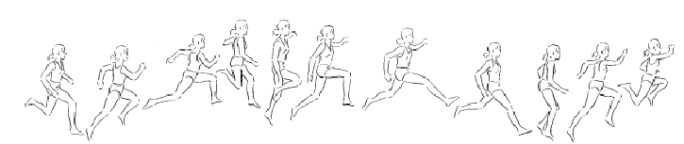
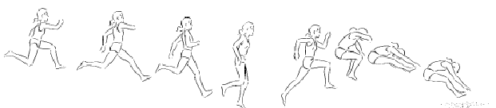
APPROACH
- Start by stepping onto your take off foot
- Mark out the start of the run up using a cone or flag
- Good, fast sprinting technique lifting the knees high
- Run fast but not too fast that you can not control your jump

HOP PHASE
- Use a low take off angle for the hop – don’t hop too high!
- Single arm action
- Move your non-take off leg upwards
- Stay tall and look forward towards the end of the pit
Think of the term
“SAME-OTHER-TOGETHER”
to help you get your hop step and jump right!
STEP PHASE
- Push off your back leg just like a bound
- Low angle take off again
- Bring your front thigh up high
- Keep your body upright

JUMP PHASE
- Still a low angle but a bit bigger than the other phases
- Use the hang technique – your teacher should have explained this already
- Keep your head and chest up

LANDING
- Both legs forward
- Push your feet ahead of your body and don’t fall backwards

