SERVE TASK 1:

- Place hoops where you think they should be for the long/deep serve and short backhand serve

- Aim for the hoops when serving
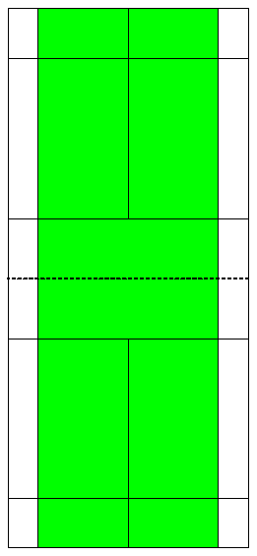
Near the hoop = 1 point
Hit the rim of the hoop = 5 points
In the hoop = 10 points

- Get as many points as you can

SERVE TASK 2:

- Have a partner on the other side of the court
- They run to a line (front of the court (BLUE)/back of the court (RED))
- You serve to where the are standing from the WHITE CIRCLE
- If they can – return the shuttle

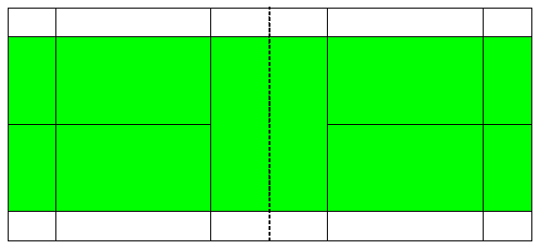

SERVE TASK 3:

- 1 person serves 5 times
- Line of people on the other side of the court trying the return the serve

