ZONE TO ZONE

EQUIPMENT: 4 soccer balls, 18 pylons

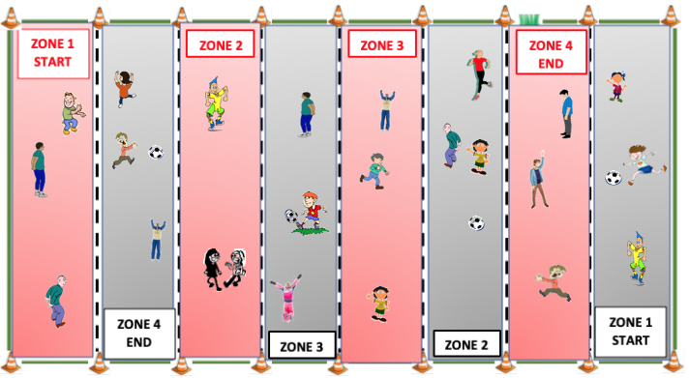
PLAYING AREA: field

SET-UP:

- Set up pylons to mark the borders of the playing area and the eight zones.

- Divide the students into two teams. In the diagram, these are shown as red and black. The diagram above is set up for a class of 24 students. If you have a different class size, adjust the number of zones and/or the number of students in each zone.

- Place two soccer balls in each start zone (Zone 1).

OBJECTIVE:

- The objective is to pass a soccer from your start zone (Zone 1) to a teammate in the end zone (Zone 4).

RULES:

- Students must stay in their assigned zones but can move freely within their zone to receive passes from teammates and to block passes from their opponents.

- The soccer balls can only be advanced one zone at a time.

- The soccer balls must be kicked. No hands allowed!

- A completed pass moves from one zone, through an opponents’ zone and is received by a teammate in the next zone. To successfully complete the pass, the receiving player must trap the ball by placing one foot on it while the ball is at rest.

- If the ball passes completely through the receiving zone or is kicked or deflected out of bounds, the opposing team retrieves the ball and takes possession in their zone.

- A point is scored every time a pass is completed in the end zone.

- Whenever you score a point, give the ball to your opponents, who will start with it in their Zone 1.

- On a signal from the teacher, all players move to the next zone. Players in Zone 1 move to Zone 2, Zone 2 moves to Zone 3, 3 move to 4, and players in Zone 4 move back to the start in Zone 1. This allows players to play in different parts of the field.

- Whenever students rotate to new positions, the soccer balls are returned to the starting position in Zone 1 for each team.

GAME VARIATION:

- Make one of the zones for each team a different size.

Zone to Zone

