
Title: Dodgeball games (2)
Type: Dodgeball games lesson ideas
Lesson Goal: different kind of dodgeball games for all levels

Instruction | Differentiation options | Extra info
On this website / link, you can find different kind of ways to play dodgeball. There are several games and rules. Just check it out and use the one which fits best to your class/level.
There’s:

Prison Ball
Dodgeball 2 vs 2
And a lot of differentiation levels.

Field set-up:
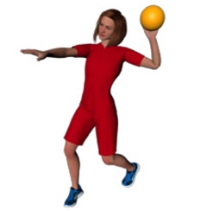

Link to support/assessment document: https://33s5zpkm02e18jqjp2oxrczu-wpengine.netdna-ssl.com/wp-content/uploads/2015/11/Secondary-Intra-School-Level-1-Competition-Cards.pdf

Additional pages if necessary:

