
Title: Dodgeball games (1)
Type: Dodgeball games lesson ideas
Lesson Goal: different kind of dodgeball games for all levels

The Dodgeball Games section provides you with resources which will help you to plan Dodgeball Games. Each game outlines what equipment is required, how to set the game up, how to play the game and how to differentiate the game.

Instruction | Differentiation options | Extra info
To find these Dodgeball games, simply click on the link and make sure you don’t press “download”, but click on the title of the tag game, from there you can find the tag game and explanation.

Bench Dodgeball
The Gauntlet Run
Submarine Tag
Superhero Tag
Secret Agent Dodgeball

Field set-up:

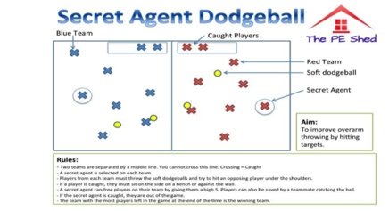



Link to support/assessment document: https://www.thepeshed.com/dodgeball-games

Additional pages if necessary:

