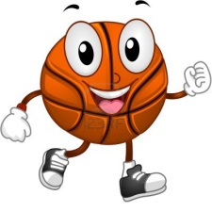Coaching Card Basketball

During your peer coaching you should identify your partner’s strengths and weaknesses while also suggesting improvements using the sentence starters and word bank below.

|  |
| --- |
| Sentence starters |
| You were able to –  Your strengths were –  You were good because –  You need to –  Your weaknesses were –  You could improve by – |

|  |  |
| --- | --- |
| **Basketball Word Bank** | |
| Grip | * Hold the ball with two hands. * Hold the ball with your fingers spread apart * Hold the ball with one hand on the side and one directly behind the ball. |
| Balance  **B** | * Stand with your feet shoulder width apart. * Stand with your feet pointing towards the basket. * Bend your knees before the shot. * Straighten your legs on the basket at all times. |
| Eyes  **E** | * Keep your eyes on the basket at all times. |
| Elbow  **E** | * Bend your elbow and position it directly under the ball. * Straighten your arm upwards towards the basket when shooting. * Release the ball just above head height. |
| Follow Through  **F** | * Straighten your shooting arm and legs at the same time. * Flick the ball with your wrist in a upwards direction towards the basket. * Hold the follow through with your fingers pointed at the target. |