**Who Stole the Gym Equipment?**

**INTRODUCTION:** This game is like *Clue.* The students will need to figure out the suspect, the piece of gym equipment that was stolen, and the location.

**EQUIPMENT:** pencils, game cards (suspect, gym equipment, location), student record sheets, secret envelope

**PLAYING AREA:** field or gymnasium

**OBJECTIVE:**

* The objective of the game is to be the first person to figure out the three cards in the secret envelope.

**SET- UP:**

* Print and cut up the game cards and student record sheets. Different cards and student record sheets will be used with different class sizes.
* Place one suspect card, one gym equipment card, and one location card in the secret envelope.
* Give each player a student record sheet and a pencil to record their information.
* Hand out one of the remaining game cards to each student. Tell them to keep this card a secret unless another student has asked for it as a part of the game. If there are extra cards, make the information known to all the students so they can check it off on their student record sheets.

**RULES:**

* You earn information by doing fitness activities, such as 15 jumping jacks, 5 push-ups, or 10 sit-ups. The fitness activities change every five minutes.
* On “Go”, find a partner and do the designated fitness activity with that partner. Once complete, you each get to question your partner about a suspect, which piece of gym equipment was stolen, and a location. For example, you might guess “Doc Johnson stole the tennis racket from the arena”. If your partner’s card matches any of those guesses, they must show you their card, which you would then write down on your own student record sheet. **In games with 10 or more players, both players would show each other their cards if either one has a correct guess**.
* Repeat with as many partners as possible. You must find a new partner between each set of guesses but may return later to requestion partners. The more exercise you do, the more information you get.
* By using deductive logic, try to figure out the 3 cards in the secret envelope. When you are ready to make a guess, tell your teacher. The first player with the correct answer wins. However, the game may be extended to allow others to finish as well.
* If you make an incorrect guess about the contents of the secret envelope, you are eliminated from competing, but you need to keep exercising and responding to guesses from other students.
* If students don’t completely solve the mystery, allow them one guess at the end of class.

**Who Stole the Gym Equipment?**

**Student Record Sheets (for up to 9 players)**

**Student Record Sheets (for 10-15 players)**

Student Record Sheets (for 16-21 players)**

If there are more than 21 players, pair a few students up to act as a single player, but make sure they only get one card.

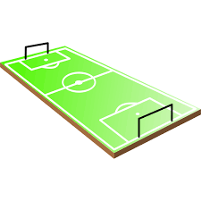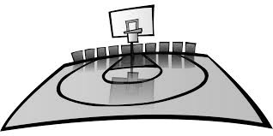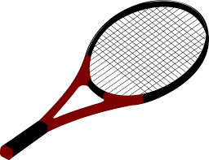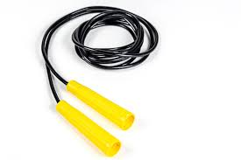

**tennis racket**

**baseball diamond**

**stadium**

**soccer field**

**gymnasium**

**skipping rope**

**golf club**

**basketball**

**Pinky Petunia**

**Doc Johnson**

**Miss Gonzales**

**Joe Athlete**

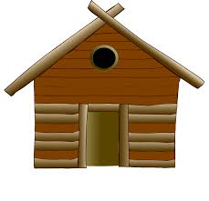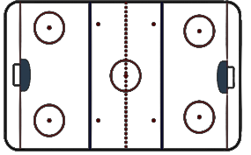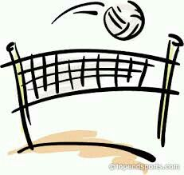

**badminton birdie**

**school**

**arena**

**boxing ring**

**fishing lodge**

**volleyball net**

**whistle**

**football**

**Thelma Thief**

**Mrs. Lovebird**

**Hector Hero**

**Mr. Gray**