Night at the Museum

EQUIPMENT: none

PLAYING AREA: gymnasium or field

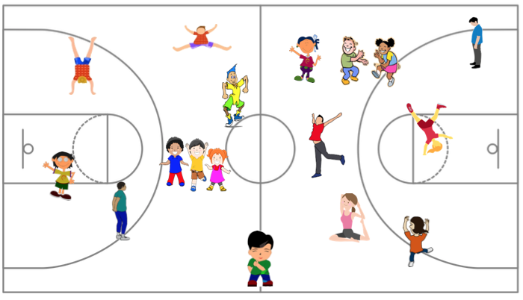

SET- UP:

- Assign one student to be the “janitor”. Everyone else is an exhibit/toy/animal.

- Have the janitor turn their back and close their eyes.

OBJECTIVE: The objective is to be the last person standing.

RULES:

- When the janitor’s back is turned, everything comes to life. Other students can dance, jump, change positions, and run around.

- When the janitor says, “Freeze”, he/she spins around and tries to catch the other students wiggling. Any violators join the janitor’s team.

- The last person standing wins.

GAME VARIATIONS:

- Give specific movement patterns for each round.

- Give specific balancing criteria for each freeze.

Night at the Museum

