**Badminton – Low Backhand Serve**

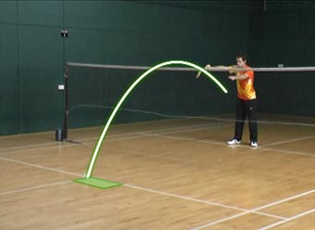

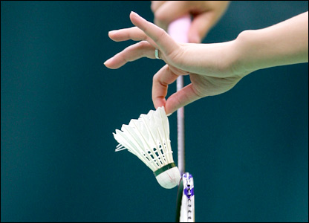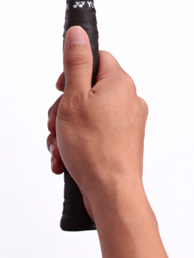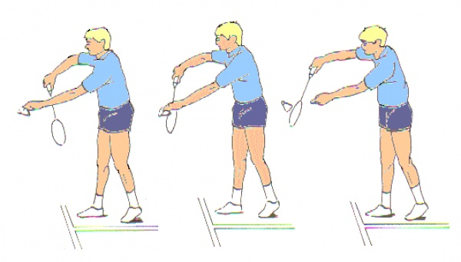

|  |  |  |  |
| --- | --- | --- | --- |
|  | **A** | **B** | **C** |
| 1. **Relaxed thumb grip on racket** |  |  |  |
| 1. **Hold racket in front of body** |  |  |  |
| 1. **Hold shuttle tips** |  |  |  |
| 1. **Place shuttle on racket** |  |  |  |
| 1. **Short backswing towards body** |  |  |  |
| 1. **Tighten grip as you PUSH through the shuttle** |  |  |  |
| 1. **Hit shuttle out of hand keeping it low over net** |  |  |  |
| 1. **Bring racket up into ready position** |  |  |  |