STEPPING-STONES

EQUIPMENT: 12 hula hoops (2 different colors or light and dark), 1 hula hoop of a neutral color, pool noodles or beanbags, 8 pylons

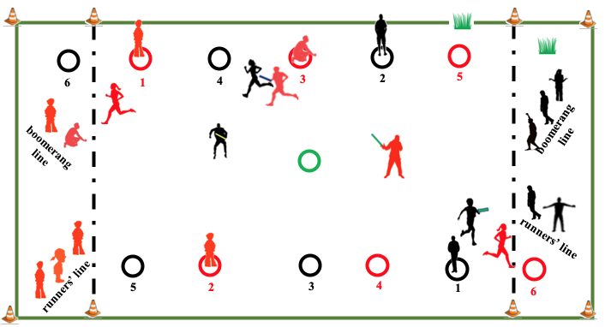
PLAYING AREA: field

SET-UP:
- Set up pylons to mark borders of the playing area and the end zones.

- Set up hula hoops in an alternating pattern as shown in the diagram. The hula hoops represent stepping-stones. Note that each team has a different color of hoops.

- Place one hula hoop of a third color in the middle of the playing area.

- Divide the class into two teams. In the diagram, the teams are red and black.

- Assign two students to be taggers from each team. Give each a pool noodle. If pool noodles are not available, they may each use their own bean bag. In this case, taggers must hit their opponent below the knees with a beanbag.

- Assign the remaining players to be runners or boomerangs.
OBJECTIVE:

- The objective is to run from stone to stone (hoop to hoop) to advance from Stone 1 (near your end zone) to Stone 6 (in your opponents’ end zone).

PLAYER ROLES:

- Runners:

- Runners try to advance from their team’s Stone 1 to Stone 6 in their opponents’ end zone without being tagged. They advance in a zigzag pattern across the field.

- Taggers:

- Taggers try to tag runners anywhere in the playing area. However, the runners are safe when they are standing inside a hula hoop.

- Boomerangs:

- Boomerangs run into the playing area, circle an opponent, and return to the back of the boomerang line.

- If they circle an opponent who is standing in a hoop, then that opponent must leave the safety of the hoop.

- If they circle a tagger on the opposing team, then the tagger must run to the hula hoop in the center of the playing area and place one foot in it before they can tag anyone.

RULES:

- Only one person is allowed in a hoop at a time. If two teammates are occupying the same hoop, they must both return to the end of the runners’ line in their end zone.

- Runners do not have to run in a straight line from hoop to hoop. However, they must still advance through the hoops in order.

- If a runner is tagged between hoops, they must return to the end of the runners’ line in their end zone.

- Only one boomerang can be active for each team at any time. When the boomerang has circled an opponent and returned to their end zone, they go to the back of the boomerang line. As soon as they are back in line, the first boomerang in the line becomes active.

- When a player arrives safely at Stone 6, they score a point. Have them tell their teacher (scorekeeper) and then return to the back of their runners’ line.

- Between rounds, players should trade places, so each player gets a chance at each role.

GAME VARIATIONS:

- Adjust the number of hoops depending on the class size.

- Include an extra tagger for each team.

- Instead of having two lines in each end zone, only have a boomerang line. Runners who are tagged become boomerangs. Boomerangs can become runners by running to Hoop 1 for their team if it is vacant.

Stepping-Stones

