**No Touch Scavenger Hunt**

**EQUIPMENT:** game forms, pencils, a variety of PE equipment or other items available in the school such as a golf ball, golf club, birdies, library book, scooter, textbook, skipping rope, beanbags, football, and basketball

**PLAYING AREA:** field

**SET-UP:**

* Create a game form (scroll down to find an example you can adjust) before class that is adapted to the materials you have available. Then make a copy for each student or team. A sample game form is included, which can easily be duplicated or adapted for your class.
* Spread out equipment in the field. Use as large an area as possible to allow the students to spread out more and to increase their activity level in moving from one spot to another. You may choose to hide some of the objects to make them more challenging to find.
* Make sure each student or team has a pencil to record their answers.

**OBJECTIVE:**

* The objective is to be the first to answer all of the questions on the game form.

**RULES:**

* Don’t touch or move the equipment.
* The first person or team to report all the correct answers wins.

**GAME VARIATIONS:**

* Add more objects or smaller objects to make the game more challenging.

**No Touch Scavenger Hunt**

**No Touch Scavenger Hunt Game Form**

Different items are scattered around the school ground. Find the item to answer each question below.

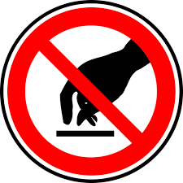

When you find each thing, look at it to get information but don’t touch or move it.

1. What brand is the golf ball? ___________________________________
2. Is the golf club right-handed or left-handed? ________________________
3. How many badminton birdies are in the pile? _______________________
4. What is the title of the library book? ______________________________
5. What color is the scooter? ______________________________________
6. What subject is the textbook for? ________________________________
7. What color of handles are on the skipping rope? _____________________
8. How many beanbags are in the pile? ______________________________
9. How many laces are on the football? ______________________________
10. What brand name is on the basketball? ___________________________
11. How many students have mostly black gym shoes?

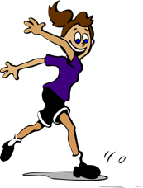When you have found all of the answers, report back to your teacher.

**No Touch Scavenger Hunt**