SHOT PUTT TEACHING CARD

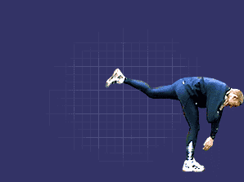
Step one

Rest the shot on the base of your fingers and push it against your neck.

Face the opposite way you’re going to throw.

Weight mainly on the right leg (if you are right handed).

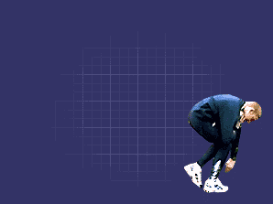
Step two
To build the power needed to throw, lower your weight onto your right leg and form a low and closed crouching position.

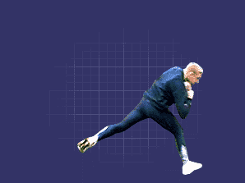
Step three

Drive your right leg downward and then powerfully thrust your left leg towards the toe board.

The power you generate here is crucial to a good throw.

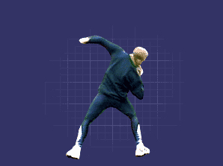
Step four

With a side-on stance, transfer the power up through the legs, body and throwing arm.

With a high elbow, release the shot by punching your arm to the sky.

Shot Putt Checklist

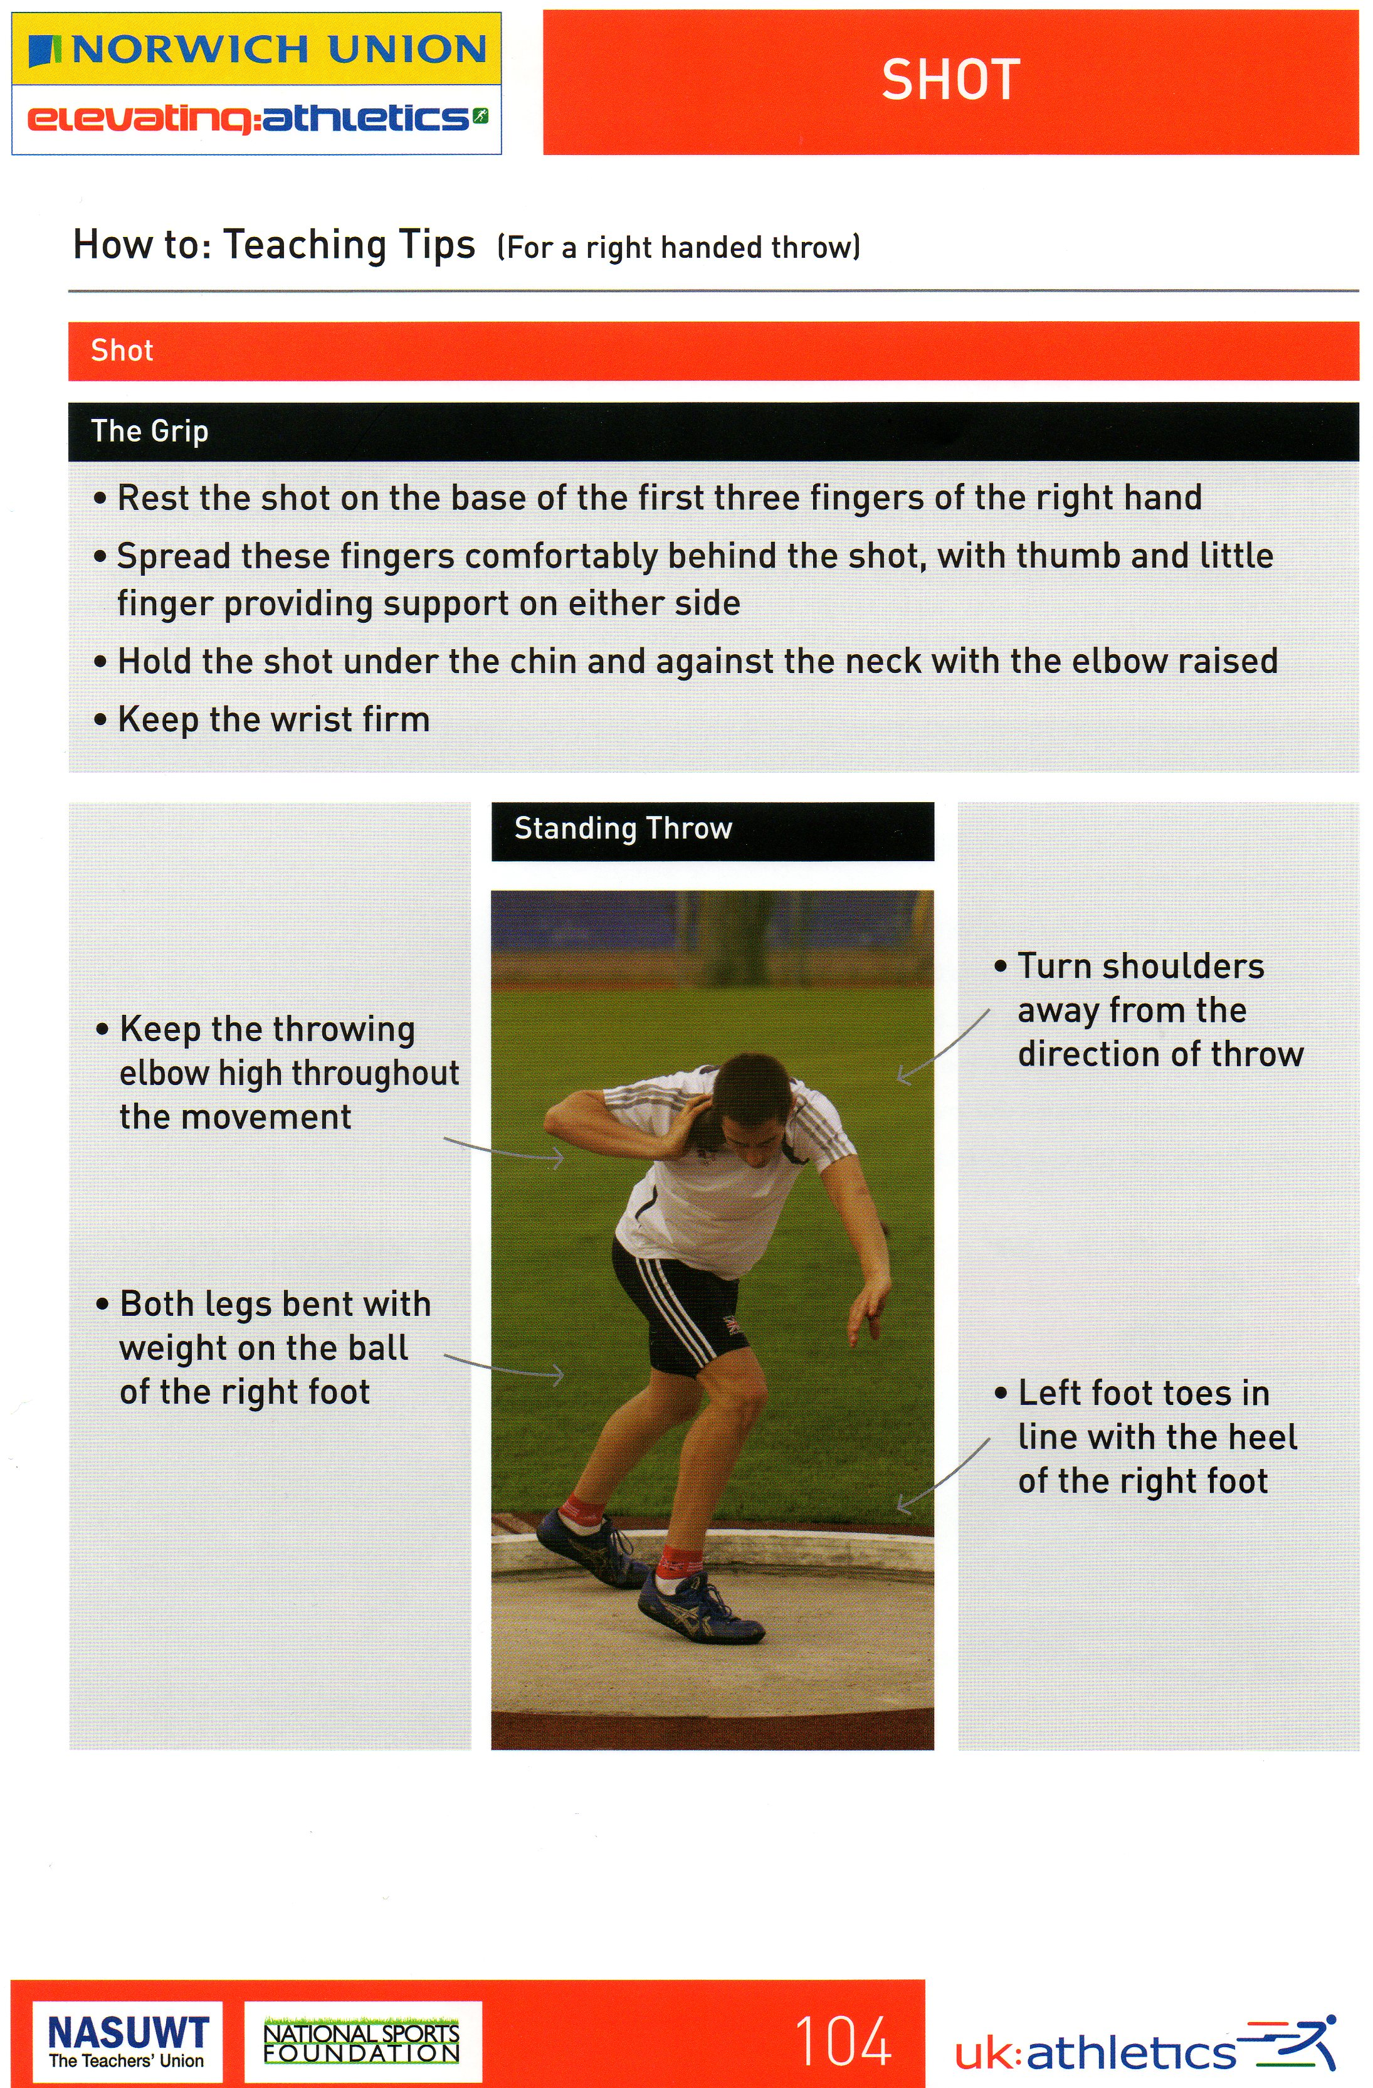
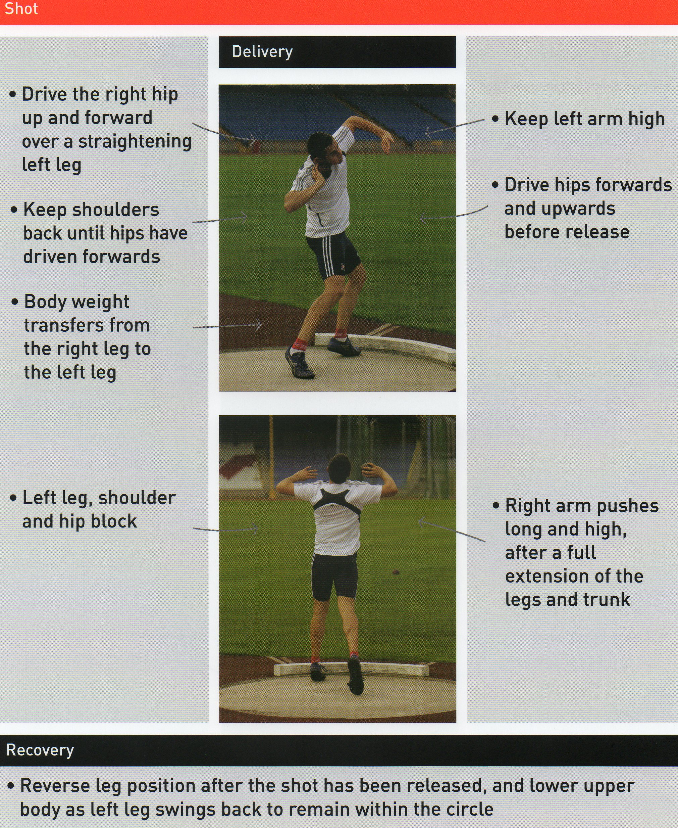
Task: Watch your partner throw 3 times. Check to see if your partner demonstrates any of the following teaching points?

 | YES | NO
Shoulders facing away from the direction of throw?

 | YES | NO
Elbow high?

 | YES | NO
Left foot toes in line with heel of right foot?
 | YES | NO
Both legs bent?

 | YES | NO
Left arm kept high?
 | YES | NO
Hips driven forwards and upwards?
 | YES | NO
Weight transfers from right leg to left leg?
 | YES | NO
Legs and body extend?
 | YES | NO
Arm pushes long and high?

