**Observation Form Sprint Class 1**

Sprinter: ­­­­­­­­­­­­­­­­­­­­_______________________ Observer:_______________________

|  |  |  |  |  |  |
| --- | --- | --- | --- | --- | --- |
| **“On your marks”** | **--** | **-** | **+/-** | **+** | **++** |
| 1. Fingers parallel to the starting line, fingers don’t touch the line. |  |  |  |  |  |
| 1. Arms extended and at shoulder width. |  |  |  |  |  |
| 1. Sprinter looks at the track 1 meter ahead of him. |  |  |  |  |  |

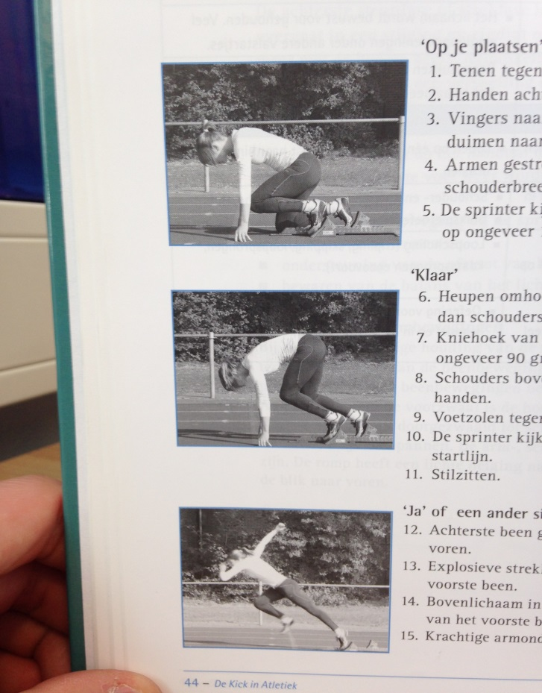

Tip:___________________________________________________________________________________

Top:___________________________________________________________________________________

|  |  |  |  |  |  |
| --- | --- | --- | --- | --- | --- |
| **“Set”** | **--** | **-** | **+/-** | **+** | **++** |
| 1. Hips go up, slightly above shoulder level. |  |  |  |  |  |
| 1. Sprinter looks at the starting line. |  |  |  |  |  |
| 1. Sprinter stays still. |  |  |  |  |  |

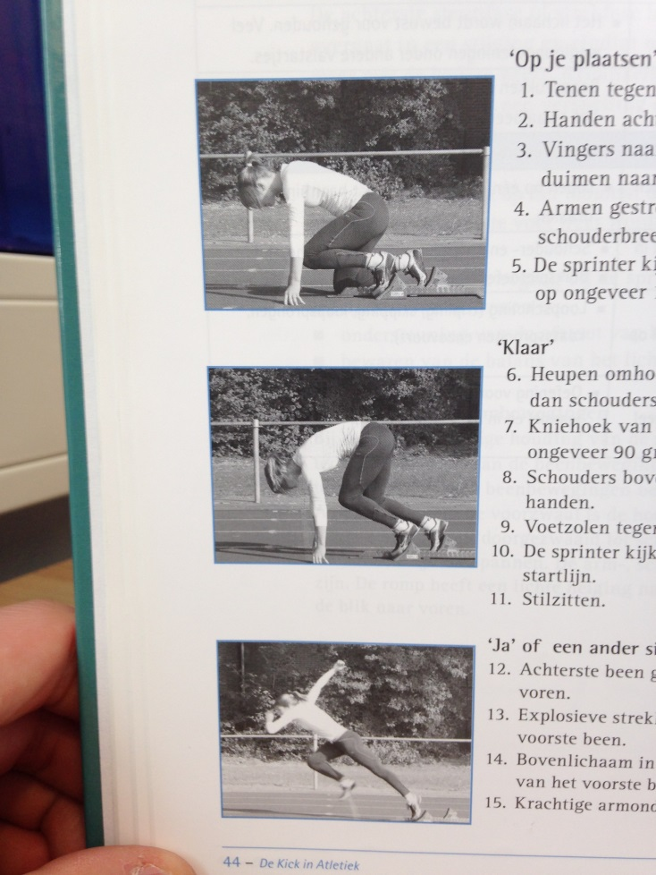

Tip:___________________________________________________________________________________

Top: ___________________________________________________________________________________

|  |  |  |  |  |  |
| --- | --- | --- | --- | --- | --- |
| **“GO!”** | **--** | **-** | **+/-** | **+** | **++** |
| 1. The leg that’s behind quickly shoots to the front. |  |  |  |  |  |
| 1. Explosive stretch of the first leg. |  |  |  |  |  |
| 1. Powerful arm support. |  |  |  |  |  |

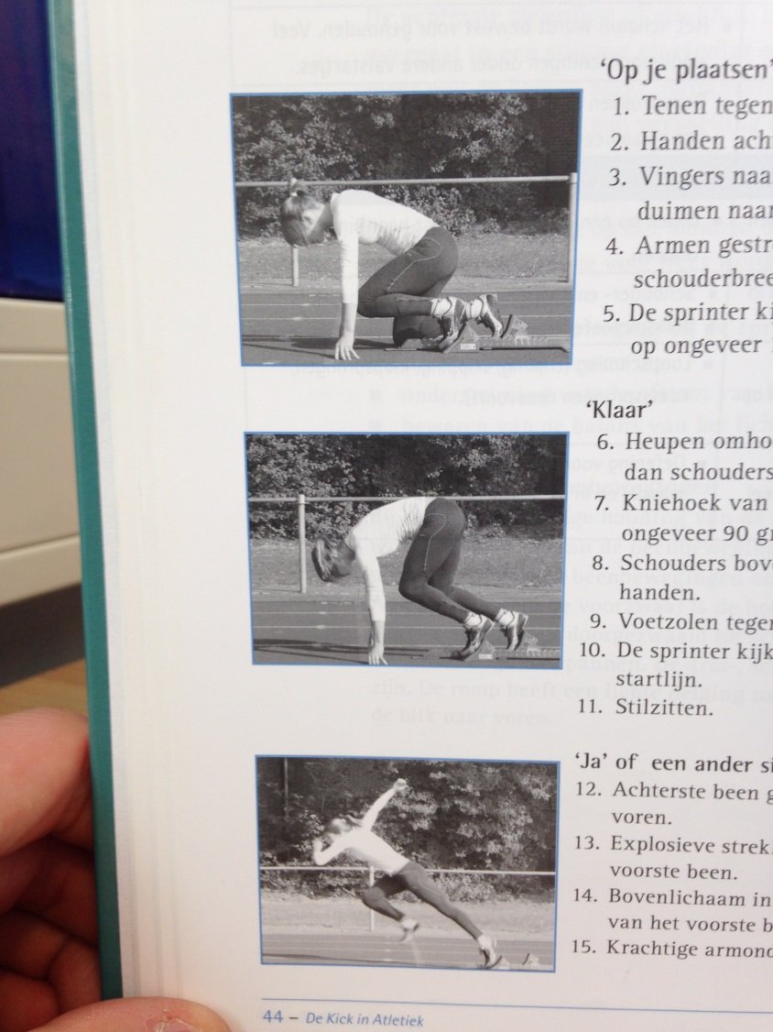

Tip:___________________________________________________________________________________

Top: ___________________________________________________________________________________