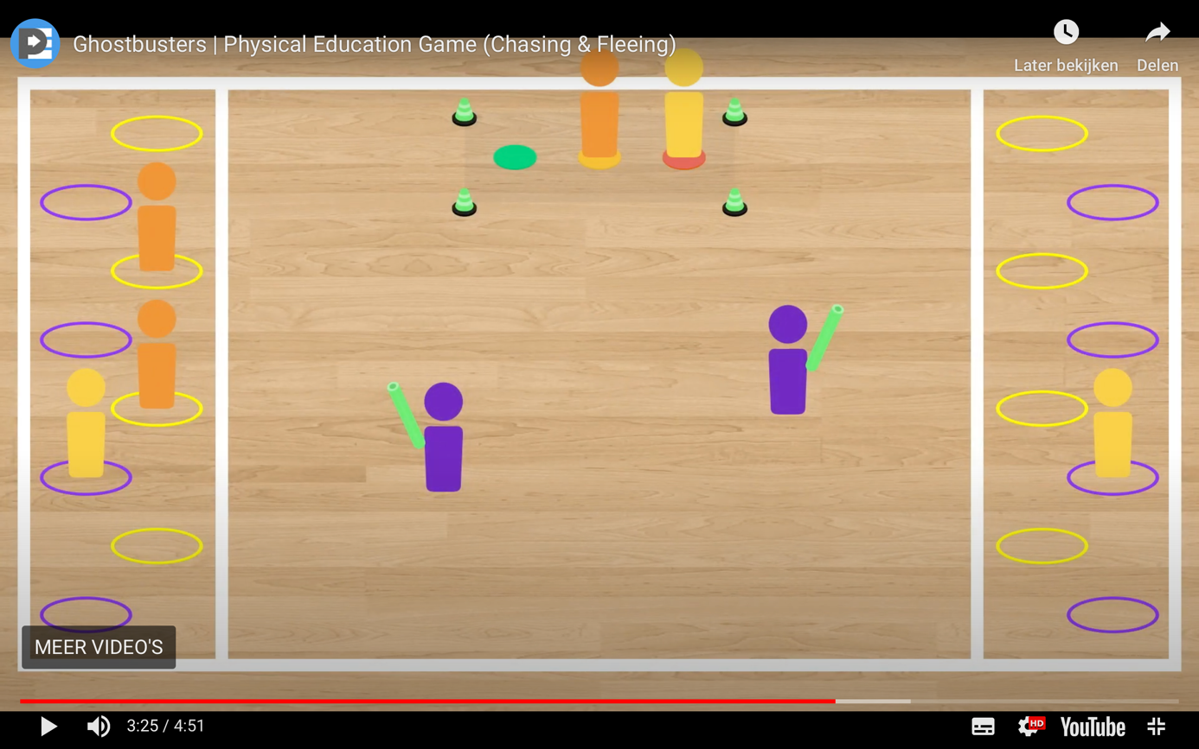

[Ghostbusters](https://thephysicaleducator.com/game/ghostbusters/) is a spooky, Halloween-themed chasing and fleeing game that was designed to help students explore tactics, resolve conflicts, and practice emotional self-regulation.

Credits go to thephysicaleducator.com

Click at the link below to find the video including explanation:

<https://thephysicaleducator.com/2012/10/30/halloween-games-for-physical-education/?ct=t(The_PhysEd_Newsletter_2_0_0022_4_2017_COPY_02)&mc_cid=668e81950a&mc_eid=d4a1622529>