GAME PLAY TASK 1:

- Around the world game
- Start with a correct serve
- Only use OVERHEAD CLEAR when above head height
- As soon as you have played your shot join the back of your queue
- Use a different way to recover the shuttle if it drops below head height

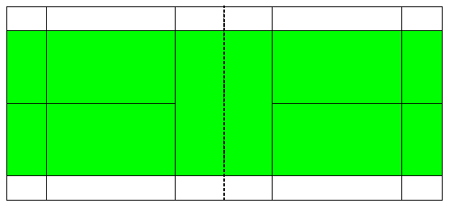

SHOT SELECTION TASK 1:

- Number Game
- Everyone has a number on the different sides of the courts
- 1’s hit to 1’s; 2’s to 2’s etc
- Let the shuttle drop below head height and only hit a forehand shot (USE THE SHEET TO HELP WITH TECHNIQUE)
- Keep the rally going – try to place it in different place (LONG/SHORT) force them to move

1
1
2
3
2
3
SHOT SELECTION TASK 2:

- Staying with your numbers from Task 1
- Link shots together
- Player 1 SERVES
- Player 2 OVERHEAD CLEAR/FOREHAND (depending on height)
- Player 3 OVERHEAD CLEAR/FOREHAND (depending on height)
- Player 4 DROP SHOT (think about where it needs to land and power needed!!!)
- Player 5 retrieve shuttle if they can with a GET SHOT (any amount of power to GET it back over the net)
- Continue again from OVERHEAD CLEAR

GAME PLAY TASK 2:

- Doubles games
- Allocate 2 coaches from your court (1 from each team) – Coaches will help with technique
- Allocate 2 umpires from your court (1 from each team) - Umpires will enforce rules and keep score (USE SHEETS TO HELP)
- Use the space for serving and game play shown in the pictures below

SERVING GAME PLAY
