Muscles and antagonists

A muscle is a band or a bundle of fibrous tissue that has te ability to contract. It produces movement of the body or makes sure that you maintain a certain position. The antagonist is a muscle that acts opposite to the specific movement generated by the agonist. It is responsible for controlling the motion, slowing it down and returning a limb in its initial position.

Assignment 1:

1. Do the exercise your teacher tells you to do
2. Discuss with your partner what the name of this muscle is
3. What is the Latin name
4. What is the antagonist
5. What is the Latin name of the antagonist?

|  |  |  |  |  |
| --- | --- | --- | --- | --- |
| Exercise | Name of Muscle  Agonist | Latin name | Antagonist | Latin name |
| Push-ups  (regular) |  |  |  |  |
| Sit-ups |  |  |  |  |
| Standing raise |  |  |  |  |
| Frog jumps |  |  |  |  |
| Bench Press |  |  |  |  |
| Sit against the wall |  |  |  |  |
| Air cycle |  |  |  |  |
| Skating |  |  |  |  |
| Push-ups  (hands together) |  |  |  |  |

Word bank

Triceps Brachii Gluteus Maximus Pectoral muscle Soleus Pectoralis Major Quadriceps

Tibialis Anterior Biceps (flexor muscle) Common shoulder muscle Back muscle Glutes

Abdominals Biceps Femoris Rectus abdominus Erector Spinae Biceps Brachii Hamstrings Quadriceps femoris Calf muscle Deltaoid Shin muscle Triceps (extensor muscle)

Assignment 2:

1. Think of an(other) exercise that trains the muscles given in the boxes.
2. Fully describe what you want your exercise to be like.
3. Practice the exercise.
4. Some of the exercises are going to be shared with your class mates.

|  |  |
| --- | --- |
| Erector Spinae |  |
| Biceps Trachii |  |
| Soleus |  |
| Rectus Abdominis |  |
| Gluteus Maximus |  |
| Pectoralis Major |  |

[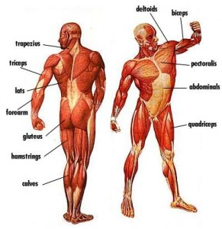](http://www.google.nl/url?sa=i&rct=j&q=&esrc=s&frm=1&source=images&cd=&cad=rja&docid=OaytNm2C6yMTOM&tbnid=GW39Fqiop1rqiM:&ved=0CAUQjRw&url=http://www.picstopin.com/271/menselijk-lichaam/http:%7C%7Cwww*biologiesite*nl%7Cfilmstripje*jpg/&ei=BNChUqCePKiS0QXI3YHoDQ&bvm=bv.57752919,d.bGQ&psig=AFQjCNHexY7mPR2NvvIVOM5kqapBQvEBew&ust=1386422605993434)