Star jumps



* Jumping into the air
* At the same time opening your legs and bringing arms out to the sides.
* *Start from a squat.*

Burpees

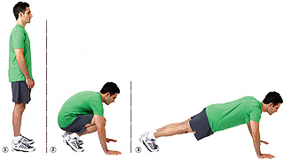

* Start from standing.
* Crouch down.
* Jump feet out to press-up position.
* Jump feet back to crouched position.
* From crouching jump up to standing.
* Land and repeat.
* *From crouching jump up to a star jump.*

Shuttle Runs

[](http://www.mainstreetevents.org/picturesofsite/woman_cartoon_running.jpg)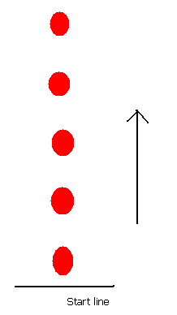

* Using different methods, move by running to the top of the cones.
* Jog back down the side of the cones on your way back

*Ideas for movement: high knees, heel flicks, skipping, cross-overs*

Tuck Jumps

[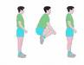](http://images.google.co.uk/imgres?imgurl=http://www.rrfh.org/images/fitness/fit_006_tjump.jpg&imgrefurl=http://www.rrfh.org/fitness.cfm&usg=__4t8OCPayA-qErnZPVlTkcPtN_iY=&h=120&w=155&sz=4&hl=en&start=4&tbnid=rX30gBPCTaEGnM:&tbnh=75&tbnw=97&prev=/images%3Fq%3Dtuck%2Bjumps%26gbv%3D2%26hl%3Den)

* Standing on the spot.
* Jump up and tuck your knees to your chest.
* Land.
* Repeat.

Side to Side Jumps

[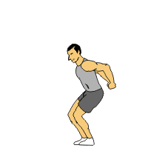](http://www.sport-fitness-advisor.com/images/plyometric_exercises_tuck_jumps.gif)

[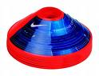](http://www.exosports.net/catalog/images/nike-training-cones.jpg)

* Stand side on to the cone.
* Jump to the other side.
* Jump back.
* Repeat

Throw and Catch

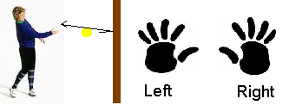

Start with ball in your right hand, throw the ball against the wall and catch with your left hand.

Now throw the ball with your left hand against the wall and catch with your right hand.

How many times can you do this?

Squat Jumps

[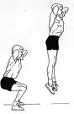](http://images.google.co.uk/imgres?imgurl=http://i.ehow.com/images/GlobalPhoto/Articles/5691286/howtoperformjumpsquat-main_Full.jpg&imgrefurl=http://www.ehow.com/video_4953231_stair-exercises-jump-squats.html&usg=__y7yi-K7yqjQQEcBeIt_GslBFB1c=&h=598&w=392&sz=30&hl=en&start=39&tbnid=3GWs0YOtL6ndsM:&tbnh=135&tbnw=88&prev=/images%3Fq%3DSQUAT%2BJUMPS%26gbv%3D2%26ndsp%3D18%26hl%3Den%26sa%3DN%26start%3D36)

Keep feet flat on the floor.

Squat down and then jump up so feet come off the floor and legs are straight.

Land and repeat.

**How many can you do?**

Throw and Clap

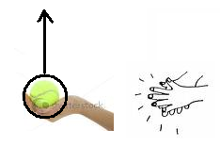

Throw the ball up

Once the ball has left your hands, clap your hands together.

Try and increase the number of claps each throw.

**How many can you do?**

Balance with

Tennis keep-ups

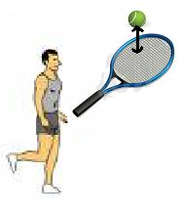

Balance on one leg whilst holding a tennis racket.

At the same time see how many times you can keep a tennis ball bouncing on the racket.

**How many can you do?**

Skipping

[](http://images.google.co.uk/imgres?imgurl=http://www.istockphoto.com/file_thumbview_approve/3129718/2/istockphoto_3129718-skipping-rope.jpg&imgrefurl=http://www.istockphoto.com/stock-illustration-3129718-skipping-rope.php&usg=__xATV-qRtnDy1vtibyI-l_fe5ccY=&h=380&w=285&sz=40&hl=en&start=39&tbnid=UbeLOUInpg4_pM:&tbnh=123&tbnw=92&prev=/images%3Fq%3Dskipping%26gbv%3D2%26ndsp%3D18%26hl%3Den%26sa%3DN%26start%3D36)

Using the skipping rope, see how fast you can skip.

Zig Zag Run

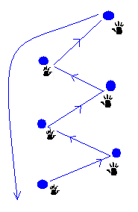

Move to each cone in the shape of a

zig-zag.

Touch every cone with your nearest hand.

Hopscotch

[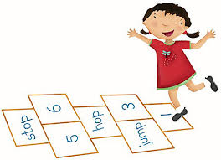](http://images.google.co.uk/imgres?imgurl=http://api.ning.com/files/MkA4RyozfPCtmlARkrijozwZDQZ2XZMOSNNWiOjDC3AM6dUs9GQ56RT*AP8ZXYpqN8GxziekZ4lwC8g7aDD5P84NLPc4JOOE/hopscotch.jpg&imgrefurl=http://2alstvirtualclass.ning.com/&usg=__y-QsOkaSxsQRWQWvAFeEzyV-RGk=&h=390&w=540&sz=49&hl=en&start=8&tbnid=FUc7lpn7xflz0M:&tbnh=95&tbnw=132&prev=/images%3Fq%3Dhopscotch%26gbv%3D2%26hl%3Den)

Using the hopscotch action (right foot, 2 foot, left foot, 2 foot etc...)

Hopscotch to the opposite cone and then run back down the side.

**How many can you do?**

3 in 1





Rub your tummy,

Pat your head,

And now jog on the spot.

Do all 3 together!

**[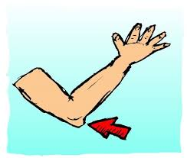](http://englishinteractive.net/IMAGES/E/elbow.jpg)**

Elbow to Knee

* Using a jumping action
* Your knee must rise up to touch your opposite elbow.
* Repeat the other side

Turn and Catch

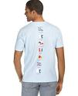[](http://images.google.co.uk/imgres?imgurl=http://www.dreamstime.com/catch-the-ball-thumb2558384.jpg&imgrefurl=http://www.dreamstime.com/item.php%3Fimageid%3D2558384&usg=__sbYXSEtjcSR2SKw3XWds611507g=&h=350&w=234&sz=64&hl=en&start=6&tbnid=oDFtbGKWkXg_sM:&tbnh=120&tbnw=80&prev=/images%3Fq%3Dcatch%2Ba%2Bball%26gbv%3D2%26hl%3Den)

Stand with your back facing your partner.

On their command they throw the ball to you.

You must turn around and catch the ball before it drops to the floor.

**How many can you catch?**