
Title: Thinking games
Type: Warming up
Lesson Goal: The PE Thinking Games section provides you with Physical Education resources which will help you to plan PE Thinking Strategy Games. Each PE Game outlines what equipment is required, how to set the game up, how to play the game and how to differentiate the game

Instruction | Differentiation options | Extra info
To find these Thinking games, simply click on the link and make sure you don’t press “download”, but click on the title of the tag game, from there you can find the tag game and explanation.

Strategicki
Kingball
The Dragon Nest
Full House
Cops and Robbers
The Wiches Cauldron
Pass the hoop
Tic-tac-toe
Peg Invasion
Pizza Knock down

Field set-up:

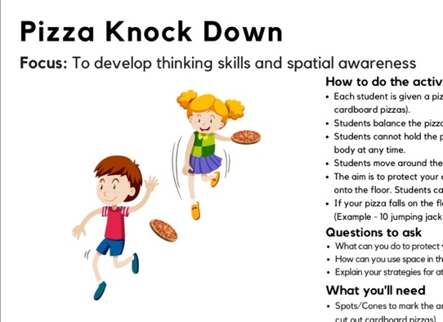
Link to support/assessment document: https://www.thepeshed.com/thinking-games

Additional pages if necessary:

