
Title: Warming up games
Type: warm up games
Lesson Goal: The PE warm up games section provides you with PE resources which will help you to plan PE Warm Up Games. Each PE Game outlines what equipment is required, how to set the game up, how to play the game and how to differentiate the game.

Instruction | Differentiation options | Extra info
To find these Warn up games, simply click on the link and make sure you don’t press “download”, but click on the title of the tag game, from there you can find the tag game and explanation.

Dangerous Dogs
Traffic Lights Football
Cat and Mouse
Peg Invasion
Dance Tag
Dragon Tails
Kings and Queens
Slide in the mud
Traffic Lights
Body Parts
Bridges and Rivers
Crossing the river

Field set-up:
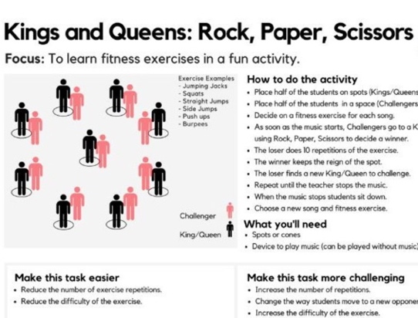

Link to support/assessment document: https://www.thepeshed.com/warm-up-games

Additional pages if necessary:

