Title: power circuit
Type: Power circuit, fitness, stamina, endurance, circuit
Lesson Goal: Getting fit.

This circuit has different stations. You work on different parts of your body and write down how you are doing. You can repeat the lesson after a while to find out if there is a difference and if you improved yourself.

Instruction | Differentiation options | Extra info
Work in pairs.  First explain all different exercises. Maybe even with an example.  Then make sure all pairs divide themselves over the different exercises.  These are the exercises:  Burpees  Bicepcurl  Sit-ups  Squat  10 meter sprint  Rope jumping  Push ups  Dips  Abdominal muscles medicine ball  Planking  All the exercises are explained in the extra sheet attached to this lesson. There is also a score sheet and for every exercise an explanation on 1 A4 so you can print it and place it next to the exercise.  Work for 1 minute while you put on the music. Give them some time to write down what they did and to change. Then another 1 minute. After that they change in the direction you explained and it starts over again.  There are 10 exercises. You can take either all exercises during 1 lesson but you can also choose to start with a different warm up and only do half of the exercises over 2 lessons. | Work alone  Increase time  Make them choose between heavier equipment.
Field set-up:
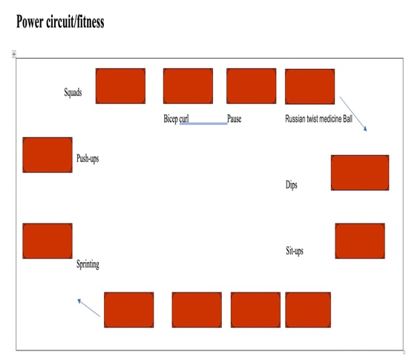

Link to support/assessment document

Additional pages if necessary:
There are attachments to this lesson you can print.

