OVERHEAD CLEAR TASK 1:

- 1 person on 1 side of the court while the others line up on the other side
- 1 person - WHITE CIRCLE serves HIGH to start off the rally
- Complete overhead clear shots 1 after the other
- Make your shot join the back of the queue
- If it drops the WHITE CIRCLE swaps with someone else
- 1 person is coaching the Overhead Clears using Ipod Video – HELP THOSE WHO NEED IT

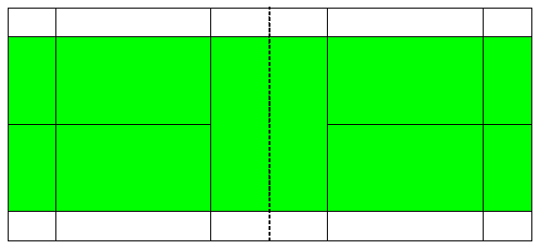

MOVEMENT TASK 1:

- Set up the court as it shows below:
- Start on the middle cone and facing the net 1 person will call a colour cone and you run to that cone

MOVEMENT TASK 2:

- Work together
- Allocate a coach from either side of the court who will watch the performance swapping in with others
- 1 Coach is looking for correct technique of the OH CLEAR and the other is looking for movement
- Set up the court
- WHITE plays a high shot to BLUE
- BLUE plays the shot back (OVERHEAD CLEAR)
- RED run to the back of the court to receive the next shot as WHITE hits it back
- Swap in

MOVEMENT TASK 3:

- Pair work – 1 on each side of the court
- (1) feeder (plays the shuttle high) (2) partner returns the shuttle using an OH Clear
- (1) plays 2 high serves (2) runs into the net then runs backwards as the shuttle is played over the net to them
- Swap over after 2 so (2) serves and (1) runs
- Ensure everyone gets a go

