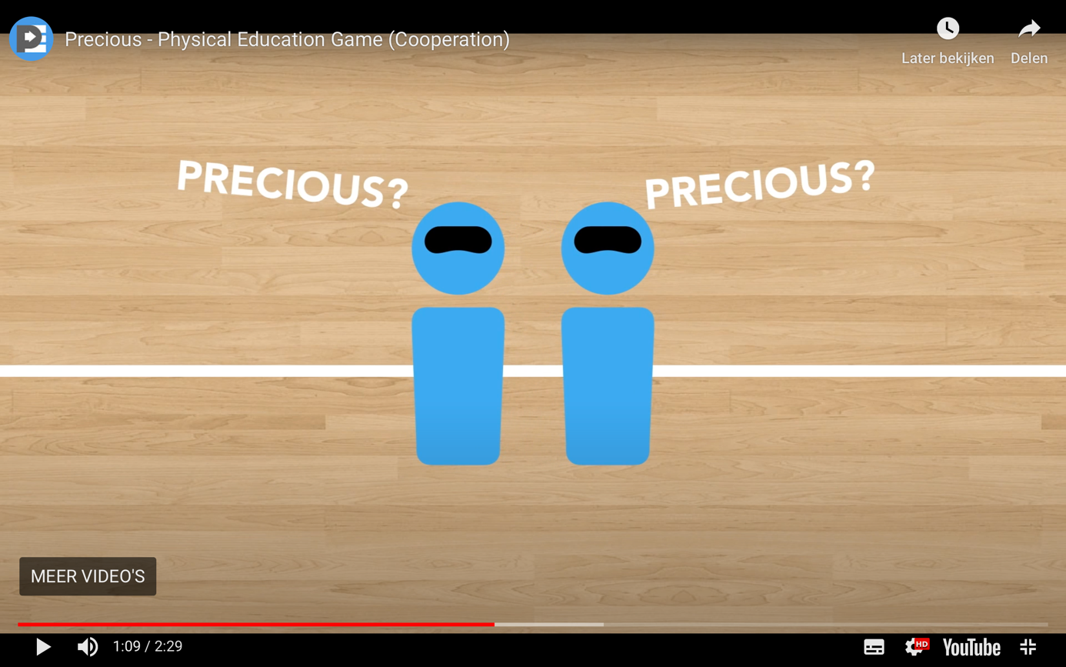

Precious is another blindfold game that I like playing with my students at Halloween. The students get such a kick out of watching their peers wander around the gym while blindfolded. Precious gets easier to find not only because there are more students forming it, but also because the amount of giggling going on makes it easier to find!

Credits go to thephysicaleducator.com

Click at the link below to find the video including explanation:

<https://thephysicaleducator.com/2012/10/30/halloween-games-for-physical-education/?ct=t(The_PhysEd_Newsletter_2_0_0022_4_2017_COPY_02)&mc_cid=668e81950a&mc_eid=d4a1622529>