Captain's Deck

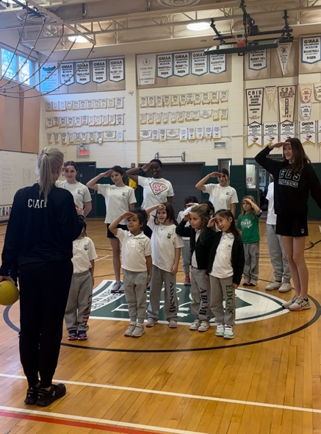

For an example, check out this youtube link. I filmed this exercise during a study trip to Canada. A special thanks to the ECS school in Montreal and Kate Walford and Susie Cleary

<https://youtu.be/RBJGdMdd1UA>

**Grade Level:**Elementary school and 1st, maybe 2nd class high school.   
  
**Skills Developed:**Teamwork, cooperation, spatial awareness, locomotor and non-locomotor skills.   
  
**Equipment Needed:**None  
  
**How to Play:**  
Designate a playing area with boundaries - this game can be played in any large open space, indoors or outdoors.

* Have students scatter themselves around the playing area.
* The "captain" (teacher) calls out orders that the players must listen to and follow.
* Below is a list of orders - you may want to adapt some of the orders so they are more suited for your students.

**Orders:**  
**To the ship:** Run to the captain's right   
**To the island**: Run to the captain's left   
**Hit the deck**: Lay down on your stomach    
**Attention on deck**: Salute and yell, "Aye, aye captain!" -- players may not   
move now until the captain gives the order of, "At ease!" (i.e. even if the   
captain gives a different order such as "to the ship" the crew must continue to   
remain at attention until told "at ease")   
**Three men in a boat**: The crew must form groups of three and sing "Row,   
row, row your boat" Anyone who is not in a group of three is eliminated from the game.   
**The love boat**: Crew members grab a partner and dance. Anybody without a   
partner is eliminated from the game.  
**Clear the deck**: Everyone must have their feet up off the floor.   
**Scrub the deck**: Everyone must get on their knees and pretend they are scrubbing the deck.  
**Captain's Quarters**: Everyone runs towards the captain.   
**Man-over-board**: Players must find a partner as quickly as possible. One   
partner must lie on their stomach while the other places their foot on their   
partner's back. Players without a partner or pairs that are too slow are   
eliminated.   
**A Periscope**: Every player falls on their back and sticks one leg in the air.  
The last ones are eliminated.   
**SHARK!!!!**: Everyone must run to a designated base (multiple bases can be   
used). The last player to the base is eliminated.   
**Crow's nest**: All players must find a partner. The lightest player rides on their   
partner's back. Those without partners or who assemble the crow's nest too   
slowly are eliminated.   
**Three maids in a row**: Children form groups of three and sit in a vertical row.  
The players who are the odd-man-out are eliminated.   
**Sick turtle**: Everyone falls onto their backs and waves hands and feet in the   
air.   
**Bow**: Run to the front of the boat   
**Stern**: Run to the back   
**Port**: Run to the left side of the boat   
**Starboard**: Run to the right side of the boat.   
**Row the Boat**: Each player finds a partner, sits face-to-face, holds hands,   
and pretends to row a boat. Players who can't find partners or who are too   
slow are eliminated.

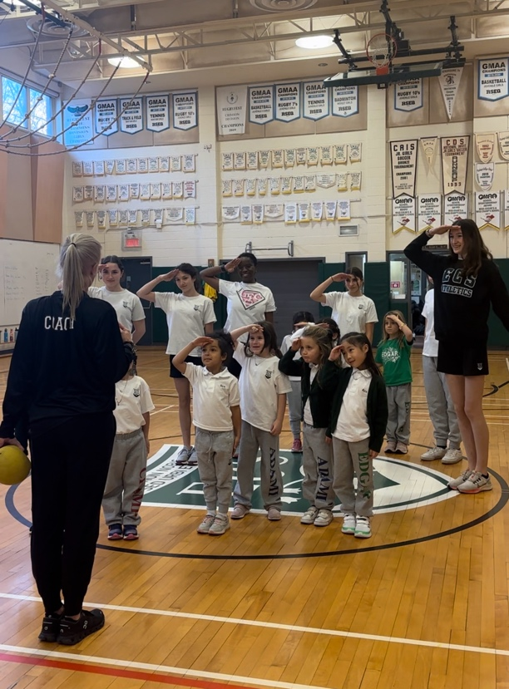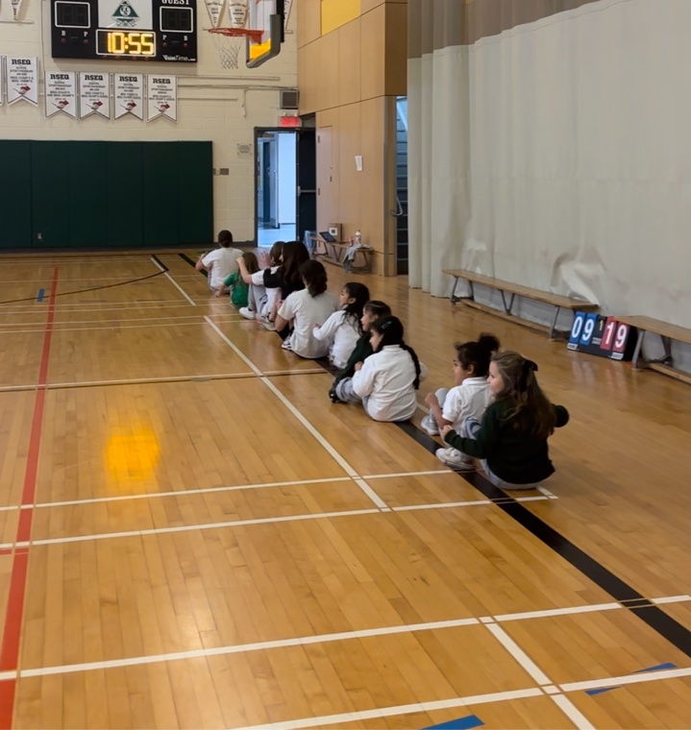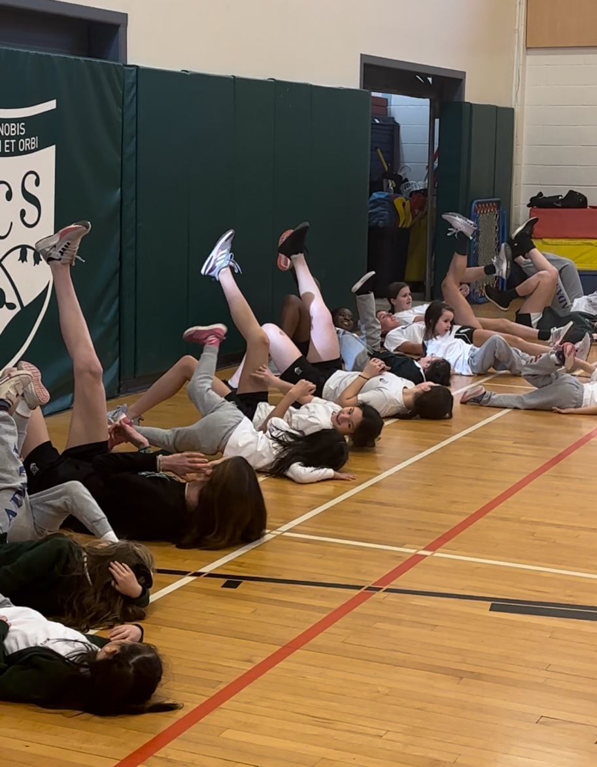

Source: <https://elementarypegames.weebly.com/captains-deck.html>