**Softball Coach Class 3**

[](http://www.google.nl/imgres?imgurl=http://westroyaltysoftball.com/news_images/org_1518/Image/softball_coach.jpg&imgrefurl=http://westroyaltysoftball.com/news.php?news_id%3D739316&h=396&w=393&tbnid=yKYCRp5PYA41oM:&zoom=1&docid=znD058Ya99cKWM&hl=nl&ei=JMJDU7-XCsbWPbyDgLAM&tbm=isch&ved=0CNMBEIQcMCc&iact=rc&dur=355&page=2&start=20&ndsp=29)

**Name:**

**Lesson 1 Softball coaching with a partner Class 3**

**Name observer:**

**Name field player:**

**Position: Pitcher, Catcher, first baseman, second baseman, third baseman, shortstop, outfielder**

(circle the position of your partner)

|  |  |  |  |
| --- | --- | --- | --- |
| FIRST INNING | correct | incorrect | What can he/she improve |
| Position in the field before the pitch |  |  |  |
| Position in the field after batting |  |  |  |
| Did he/she made the correct decision  when the ball was batted |  |  |  |

**Name observer:**

**Name field player:**

**Position: Pitcher, Catcher, first baseman, second baseman, third baseman, shortstop, outfielder**

(circle the position of your partner)

|  |  |  |  |
| --- | --- | --- | --- |
| SECOND INNING | correct | incorrect | What can he/she improve |
| Position in the field before the pitch |  |  |  |
| Position in the field after batting |  |  |  |
| Did he/she made the correct decision  when the ball was batted |  |  |  |

**Lesson 2 Softball coaching with a partner Class 3**

**Name observer:**

**Name field player:**

**Position: Pitcher, Catcher, first baseman, second baseman, third baseman, shortstop, outfielder**

(circle the position of your partner)

|  |  |  |  |
| --- | --- | --- | --- |
| FIRST INNING | correct | incorrect | What can he/she improve |
| Position in the field before the pitch |  |  |  |
| Position in the field after batting |  |  |  |
| Did he/she made the correct decision  when the ball was batted |  |  |  |

**Name observer:**

**Name field player:**

**Position: Pitcher, Catcher, first baseman, second baseman, third baseman, shortstop, outfielder**

(circle the position of your partner)

|  |  |  |  |
| --- | --- | --- | --- |
| SECOND INNING | correct | incorrect | What can he/she improve |
| Position in the field before the pitch |  |  |  |
| Position in the field after batting |  |  |  |
| Did he/she made the correct decision  when the ball was batted |  |  |  |

**Lesson 3 Softball coaching with a partner Class 3**

**Name observer:**

**Name field player:**

**Position: Pitcher, Catcher, first baseman, second baseman, third baseman, shortstop, outfielder**

(circle the position of your partner)

|  |  |  |  |
| --- | --- | --- | --- |
| FIRST INNING | correct | incorrect | What can he/she improve |
| Position in the field before the pitch |  |  |  |
| Position in the field after batting |  |  |  |
| Did he/she made the correct decision  when the ball was batted |  |  |  |

**Name observer:**

**Name field player:**

**Position: Pitcher, Catcher, first baseman, second baseman, third baseman, shortstop, outfielder**

(circle the position of your partner)

|  |  |  |  |
| --- | --- | --- | --- |
| SECOND INNING | correct | incorrect | What can he/she improve |
| Position in the field before the pitch |  |  |  |
| Position in the field after batting |  |  |  |
| Did he/she made the correct decision  when the ball was batted |  |  |  |

**Name observer:**

**Name field player:**

[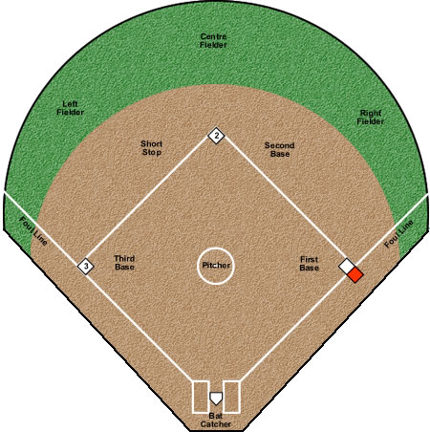](http://www.google.nl/url?sa=i&rct=j&q=&esrc=s&frm=1&source=images&cd=&cad=rja&uact=8&docid=viktblbZtolyFM&tbnid=t0nbAU-gwWTjjM:&ved=0CAUQjRw&url=http://www.playsoftball.ca/pages/on-the-diamond/types-of-softball/orthodox-softball/what-is-orthodox-softball.php&ei=dsRDU_L3MYbZObrhgZgN&bvm=bv.64367178,d.ZWU&psig=AFQjCNHlp9tyrBrmCjkGgoKV3A4EpAc6bg&ust=1397036497842175)