Rope-skipping year 1
Aim/Goal
Work together in pairs
Learn rope-skipping techniques
Learn technical terms about rope-skipping

Lesson
- Get into pairs and go stand next to a rope (DEMO)
- Running dictation
- Hand-out a revise form (pick-up the form and show the form you filled in) Exchange with another pair and check the answers.
Points: start with 20. For every wrong word -1 and for every small mistake or wrong punctuation -1/2
- Practice the exercises on the forms. One is doing the exercise and the other one is the coach. Don’t forget to swap around

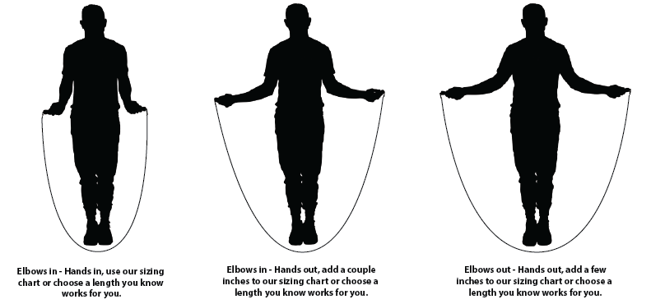
Hold on to the rope and measure the length.

Keep your arms at an angle of ninety degrees.

The rope should touch the ground while you are holding it in your hands.

Page 1

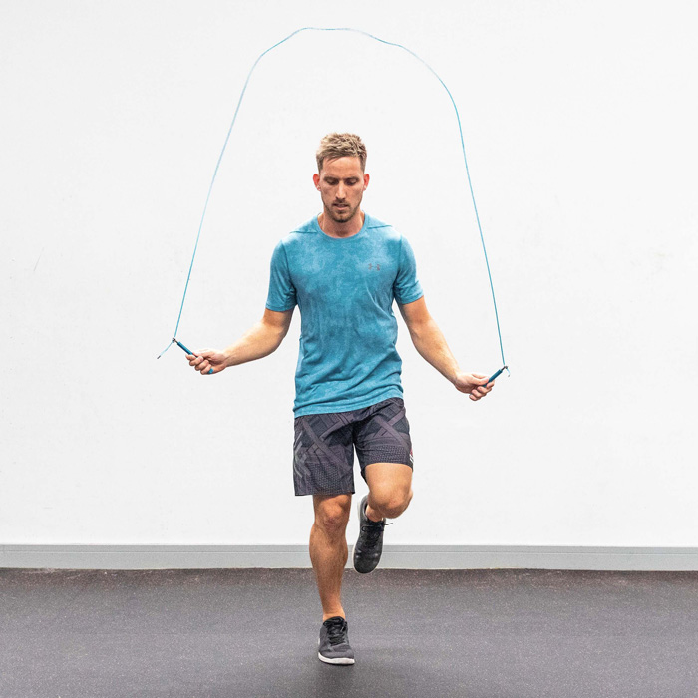Turn the rope and jump over it. Every time the rope goes round, you jump.

Use your wrists to turn the rope. Keep your elbows in, close to your waist.
Find a pace that suits you. You must maintain this speed for a long period of time.
Page 2
_______ __ to the rope and
________ the length.

Keep your arms at an _____ of ninety degrees.

The rope should touch the ground while you are _______ in your ______.

Page 1

Turn the rope and ____ ___it. Every time the rope _____ ______, you jump.

Use your ______ to turn the rope. Keep your _____ in, close to your ______

Find a ____ that suits you. You must ______ this speed for a _______ of time.

Page 2

