Self Defense (Pysical contact games)

Learning goals You are able to:
- Physical games on the floor and applying them in a game
- Making the other lose balance
- Applying the rules of holding and liberating;
- Organizing and ruling a tournament;

Important points You are able to:
- Create a tournament on paper, including the rules for awarded points when you win, draw or lose and a schedule, all the referees and all the materials used.

Test In the lesson:
- The last lesson by the teacher;
- You will be judged as a group, for the preparation and execution.

The Test lesson

You have to invent a physical game in groups of minimum 4 or maximum 6. You have to invent rules and make up a tournament for the last lesson. In the lsseon you have seen a number of examples of games. If you have a game you make all the rules and regulations on paper.

Conditions
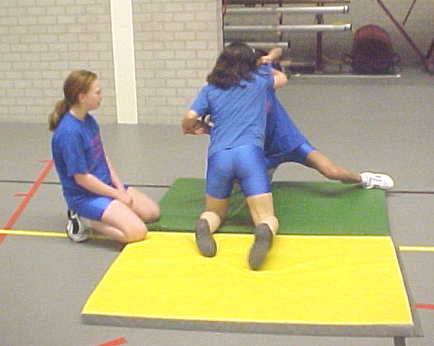
- The lesson starts when you come into the gymnasium
So start right away !!!!
- The game is played on the floor
- You have forms to keep the score
- Two referees guide the game
- One of the referees is a timekeeper
- Take care of a good watch
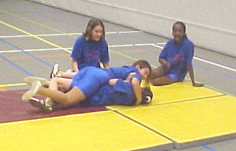
- Evert match has a maximum of three minutes.
- Make rules.

Every item that is missing means a deduction on
your grade.

Names of those in a group:
1. | 3. | 5.
2. | 4. | 6.

Explanation of the game

What are the rules of the game?
7.
8.
9.
10
11.
12.

Which rules are most important for the referee?

We play with the following schedule (cross)
4 people | 5 people | 6 people
1-2  3-4  1-3  2-4  1-4  2-3  nr. 3- nr. 4  Winner – nr. 2 | 1-2  3-4  5-1  2-3  4-5  1-3  2-4  5-3  1-4  2-5 | 1-2  3-4  5-6
1-2  3-4  1-3  2-4  1-4  2-3  nr. 3- nr. 4  Winner – nr. 2 | 1-2  3-4  5-1  2-3  4-5  1-3  2-4  5-3  1-4  2-5 | Winners | Losers
1-2  3-4  1-3  2-4  1-4  2-3  nr. 3- nr. 4  Winner – nr. 2 | 1-2  3-4  5-1  2-3  4-5  1-3  2-4  5-3  1-4  2-5 | W1-W2  W1-W3  W2-W3 | V1-V2  V1-V3  V2-V3
8 games | 10 games | 9 games

Score
1. |  | 3. |  | 5.
2. |  | 4. |  | 6.

Grade given by the teacher:

