Lesson 2

1 Card sort.

(showing it) Get into pairs and go stand next to a rope. In the gym you will see several cones. Underneath every cone you can find a picture of an exercise. Go and stand next to the rope you picked in your pair. You run to the cones and retrieve the picture. Practice the exercise for 30 seconds or 20 jumps.

When you have finished bring the picture back and go to the next one.

Coaching : support language (choose 5 and 3 of them are new)

2 Score grid:

Name pair, Name exercises, Easy, Average, Difficult, Extra , (Fun)

Jump with your feet together

Jump Side to side (skiing)

Skip jumps (change left and right with every jump)

Jump with high knees one by one

High Jumps

Jump in the front and back (snowboarding)

Extra card

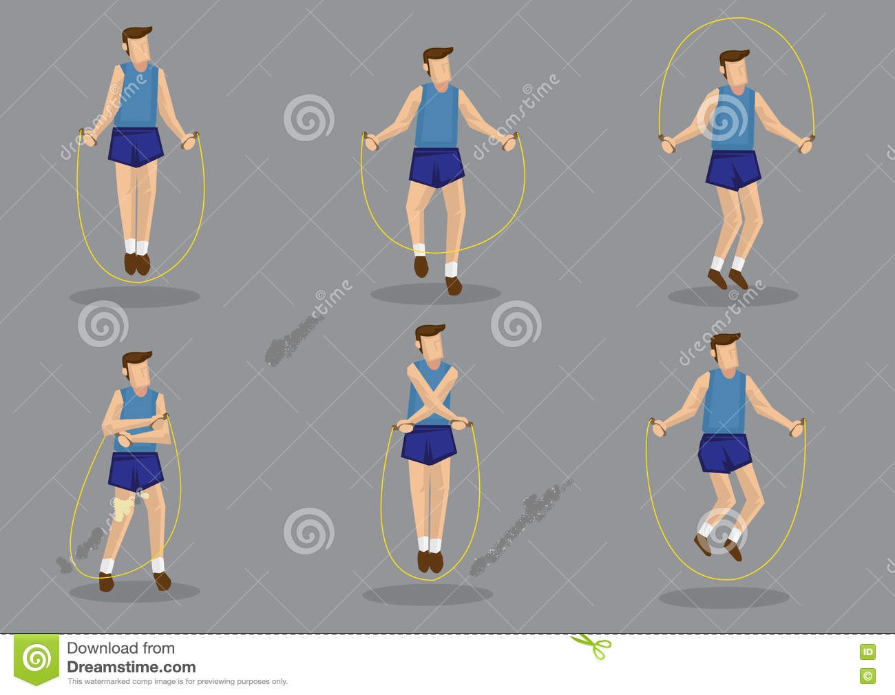

Cross your arms in front of you and jump (keep your elbows tight to each other)

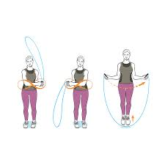

Wave the rope from side to side and jump

½ turn to jump from front to back and try to turn back

Coach

One Eleven

Two Twelve

Three Thirteen

Four Fourteen

Five Fifteen

Six Sixteen

Seven Seventeen

Eight Eighteen

Nine Nineteen

Ten Twenty

Come on, keep on going! You are getting there Don’t give up!

You can do it! Almost, try again Let’s start

Let’s go Run fast Well done!

Turn your wrists Don’t jump too high Look straight a head

Keep your feet together Keep your elbows in Try to go faster

Not that fast Breathe in through your nose Get your knees up

You are doing great Good job Let’s go to the next one

It’s my turn Who’s going to start? Are you ready?

***CHOOSE 2 YOU ALREADY KNOW AND 3 WHO ARE NEW FOR YOU***