
Title: CLIL activity
Type: groups
Lesson Goal: work in squads

Instruction | Differentiation options | Extra info
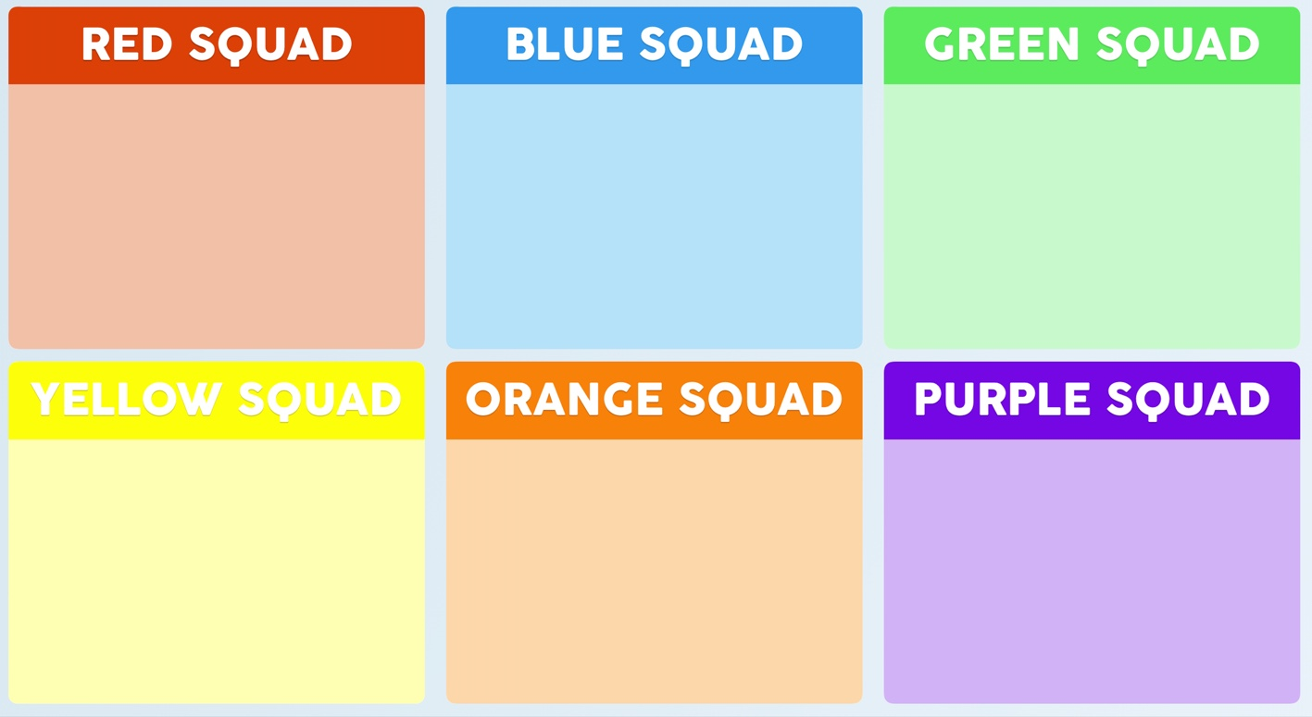
Field set-up:
Prepare this period and divide your class in squads. Write/type down the names and explain your students which squad they are in. Every time you want them to talk to each other about a topic/exercise or you need groups for something else, call out: squad up.
You don’t have to work in these groups all the time, because you might want to differentiate within levels but whenever you need a group to talk about things, or discuss something, than make them squad up. It works!
Credits are for the physicaleducator.com you can find more at their website about this.

Link to support/assessment document; www.thephysicaleducator.com

Additional pages if necessary:

