|  |  |  |
| --- | --- | --- |
| Group members |  | Points |
|  |  |  |
| How many activities did you do? |  |  |
| Did you speak English all the time? |  |  |
| Write down some expressions you used? | 1.  2.  3.  4.  5. |  |
| Write down some of the phrases you used? | 1.  2.  3.  4.  5. |  |

1. Divide the class in groups of four.
2. Place the assignments upside down on the floor on the other side of the gym.
3. Number 1 has to run to one of the papers read the paper and run back to his/her teammates. He/She explains the assignment. The whole group has to do the assignment. Once they are done another team member runs to the other side of the gym and reads the next assignment.
4. (Take care of each other, it can be crowded in the gym)

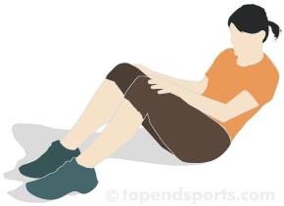

20x Explain in full sentences.

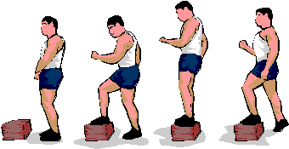

20x use a bench. Explain in full sentences!!!

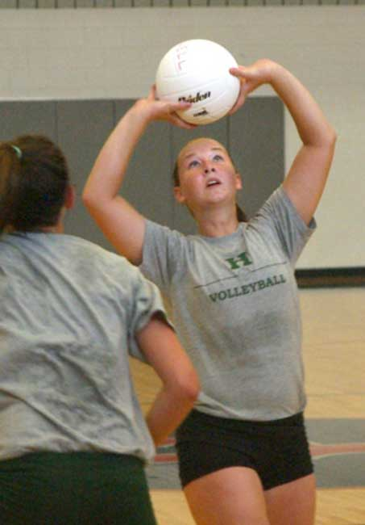

10x /Pairs. Overhead pass. Explain in full sentences.

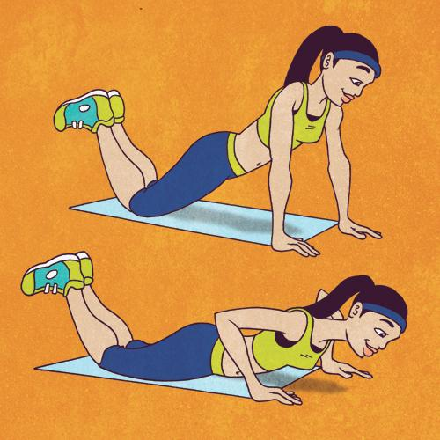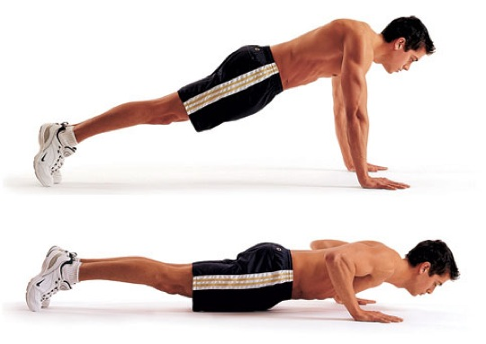

Boys Girls

10x. Explain in full sentences.

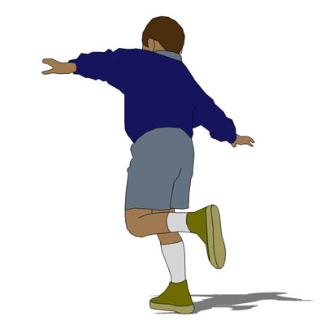

Other side of the gym. Other leg back. Explain in full sentences.

[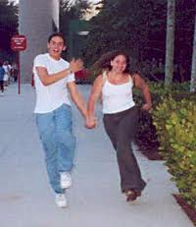](http://www.google.nl/imgres?start=91&biw=1280&bih=843&tbm=isch&tbnid=vk0e70K8eI6bkM:&imgrefurl=http://www.noelkingsley.com/blog/archives/2008/01/skipping.html&docid=Md4zamAiEU1y2M&imgurl=http://www.noelkingsley.com/blog/carl_and_sara_skipping.jpg&w=250&h=289&ei=-GyfUfqAHaqO0AX62YGgDw&zoom=1&iact=hc&vpx=748&vpy=493&dur=874&hovh=231&hovw=200&tx=77&ty=170&page=3&tbnh=141&tbnw=135&ndsp=51&ved=1t:429,r:22,s:100,i:70)

Other side of the gym and Back. Explain in full sentences.

[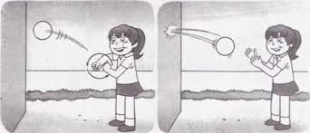](http://www.google.nl/imgres?biw=1280&bih=843&tbm=isch&tbnid=sUoPwlbaPWPUMM:&imgrefurl=http://physical-education-training.f1cf.com.br/physical-education-training-22-training-of-skill-with-the-ball.html&docid=KwKtpexx95ycSM&itg=1&imgurl=http://physical-education-training.f1cf.com.br/images/ed_fisica_desportos-23.jpg&w=541&h=234&ei=jG2fUYbNM4Gr0QWt-YGoCA&zoom=1&iact=rc&page=3&tbnh=131&tbnw=266&start=76&ndsp=45&ved=1t:429,r:81,s:0,i:328&tx=204&ty=75)

Catch 10x. Tennis ball. One throws, other catches. Explain in full sentences.