PUSH UPS

Push ups on your knees: |  |  | Push ups in press up position:
5 times | 1,0 |  |  | 5 times | 2,0
10 times | 1,0 |  |  | 10 times | 4,0
15 times | 2,0 |  |  | 15 times | 6,0
20 times | 4,0 |  |  | 20 times | 8,0
25 times | 6,0 |  |  | 25 times | 10,0

The execution has to follow the following requirements:
- Lower your body until your lower arms make a ninety degree angle with your upper arms;
- Your whole body has to stay as straight as a board;
- Your trunk, hips and legs stay in a straight line

You will get four out of ten if you fail to execute the technique properly.

Wrong execution: Correct execution:
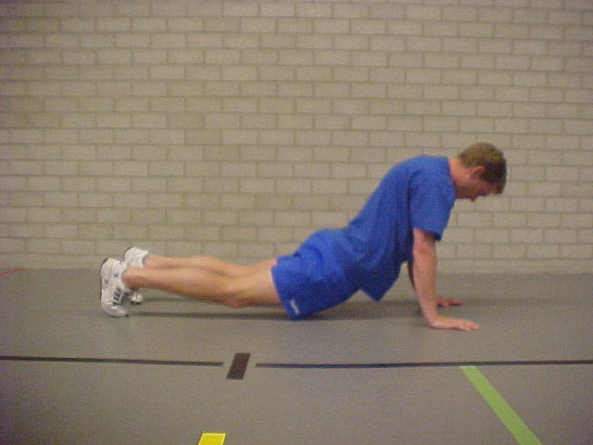
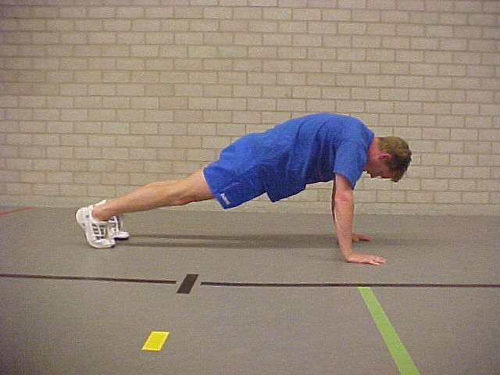
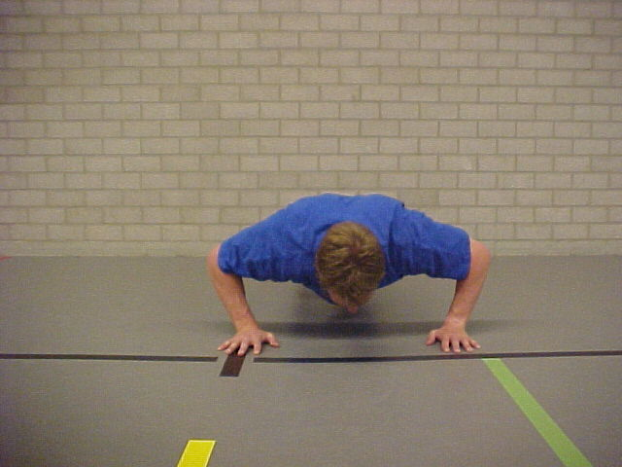

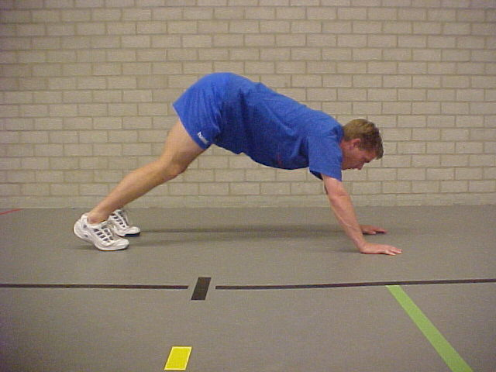

Your score: x 0.4, so your grade is:

Pass this mark to your teacher

