Title: Coordination games
Type: Games Coordination
Lesson Goal: the PE Coordination Games section provides you with Physical Education resources which will help you to plan PE Coordination Games. Each PE Game outlines what equipment is required, how to set the game up, how to play the game and how to differentiate the game.

Bench Ball

Instruction | Differentiation options | Extra info
To find these Coordination games, simply click on the link and make sure you don’t press “download”, but click on the title of the tag game, from there you can find the tag game and explanation.

Protect the Pin
Crab Football Clearout
Protect the Kingdom
Meteor Battle
Tower Rush
Bench Ball
Clap Catch
King of the Pin
Bench Tag
Meteor Ball
Ladder PE Tasks
Hoop Colour Coordination
Bean Bag Bucket Tag

Field set-up:
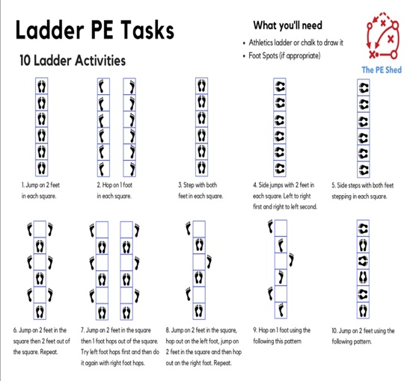

Link to support/assessment document: https://www.thepeshed.com/coordination-games

Additional pages if necessary:

