Title: Tag games
Type: warming up
Lesson Goal: Nice Tag games to use during Warming Up.


PE Games Games section provides you with Physical Education resources which will help you to plan PE Tag Games. Each PE Game outlines what equipment is required, how to set the game up, how to play the game and how to differentiate the game.

Instruction | Differentiation options | Extra info
To find these Tag games, simply click on the link and make sure you don’t press “download”, but click on the title of the tag game, from there you can find the tag game and explanation.

Amoeba Tag
Balance Tag
Dead Ants
Fitness Tag
Pokemon Tag
Recharge!
Spiders and scorpions
Submarine Tag
Chain Tag
Toilet Tag
Polar Bear Tag
Bean Bag Bucket Tag
Field set-up:
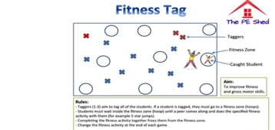

Link to support/assessment document: https://www.thepeshed.com/tag-games

Additional pages if necessary:

