Long Kick

EQUIPMENT: soccer balls or dodgeballs, pylons

PLAYING AREA: field
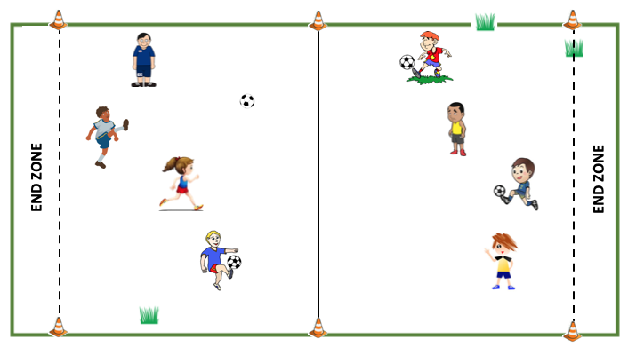

SET- UP:

- Have students find a partner and a ball to share. Then have them spread out across the field.

OBJECTIVE:

- The objective is to kick your ball to your opponent’s end zone.

RULES:

- Start at the center line.

- You are only allowed to touch the ball with your feet.

- Alternate kicks with your partner. You kick once toward your opponent’s end zone. Then they kick it back in the opposite direction toward your end zone.

- After each kick, the ball must come to a complete stop.

- If you touch the ball while it’s moving, your opponent gets two kicks in a row.

- Follow the teacher’s instructions about how you are to kick the ball (examples – regular kick, kick with your non-dominant foot, kick backwards with your heel, kick while laying down). Change kick types every couple of minutes.

- If you get the ball to one of the end zones, go back to the center line and try again but switch directions.

GAME VARIATIONS:

- Have more than one person on a team and take turns kicking.

- Use a different type of ball, such as a beach ball.

Long Kick

