Top Rope Belaying - An Eight Step Guide

Below is a simple guide to the art of Top Rope belaying, the first thing any climber needs to learn before venturing outside or even to a wall. It is a pretty simple technique which uses a ***belay device*** (friction plate) to trap the climbing rope when pressure is applied to it i.e. when the climber falls, allowing the belayer to be able to hold their partners weight quite easily

There is only really one golden rule; never, ever, let go of the rope ***below the belay device***, - as it is this rope (the control or ***‘dead’ rope )*** which allows you to hold your partner should they fall. The rope above the belay device (or ***‘live’*** rope) cannot be used to hold a fall - it hasn’t travelled through the belay device and therefore would burn your hands very badly if you tried to take someones weight on it alone.

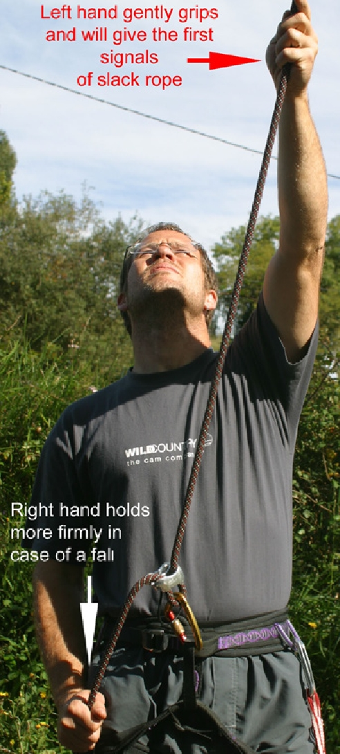

***Step 1***

The starting position is as shown here. The RH is on the ‘dead’ rope - the rope below the belay device - and the LH gently grips the ‘live’ rope - above

the belay device. It is this higher LH which will get the first signals of ‘slack’ rope as the climber moves up the rock. My personal method is almost to lean on the the upper rope so that as it becomes ‘slack’ it

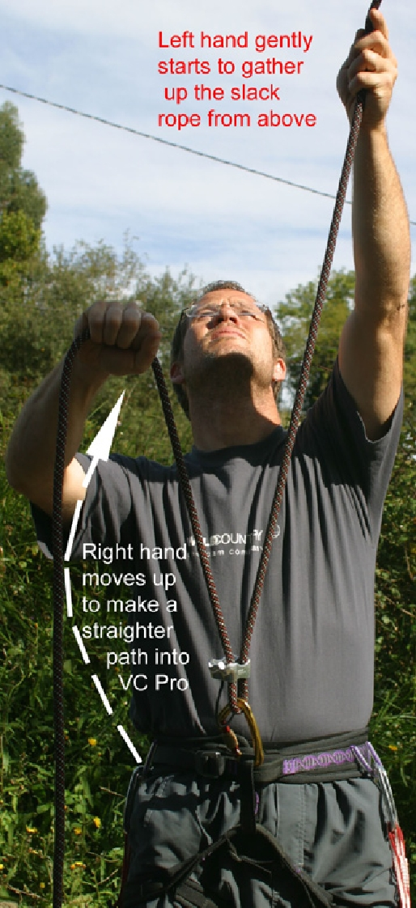

is really obvious as you will start to fall forward.

When this happens you need to move to Step 2....

***Step 2***

All belay devices are designed to give friction and they do so by bending the rope through a tight an-gle. So to make it easier to ‘take in’ any slack rope you are best lessening this angle . This is done by raising the RH so it takes the ropes to an almost par-allel position giving a smooth ‘in-out’ through the belay device. As this is happening the LH starts to gently pull down the slack that has appeared above.

From this position one moves to Step 3

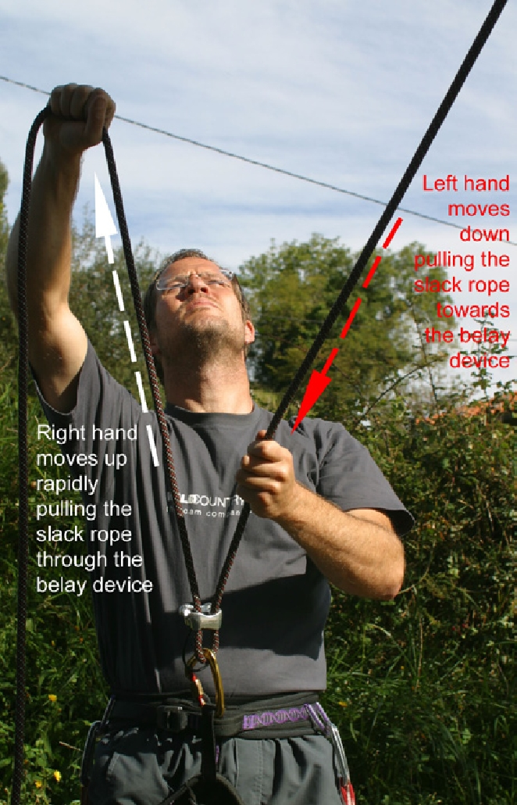

***Step 3***

The left hand grips tigher & pulls the rope down towards the device taking up as much slack rope as possible. The right hand pulls up and away from the device at the same time, smoothly drawing the rope through until either there is no more rope to pull or the arm is at full extension.

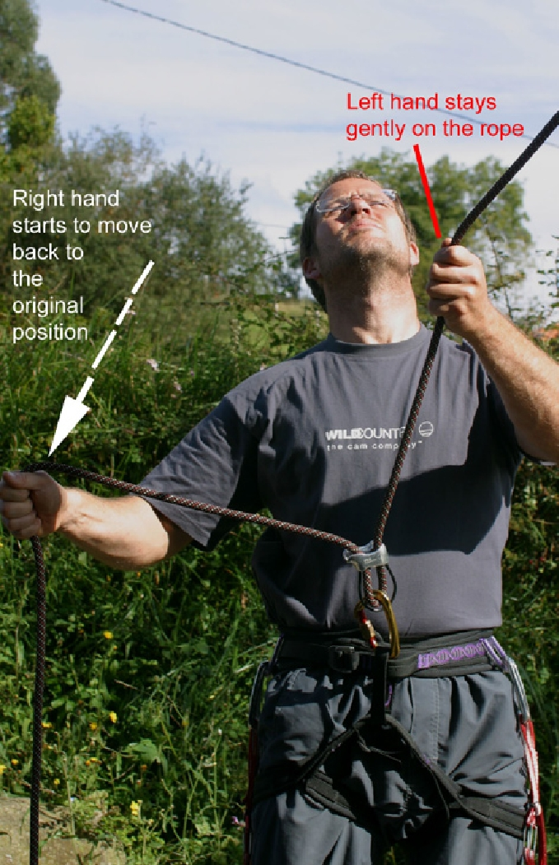

***Step 4***

The right hand then moves in an arc back down towards the side - the starting posi-tion. While the left hand stays gently on the ‘live’ rope.

***Step 5***

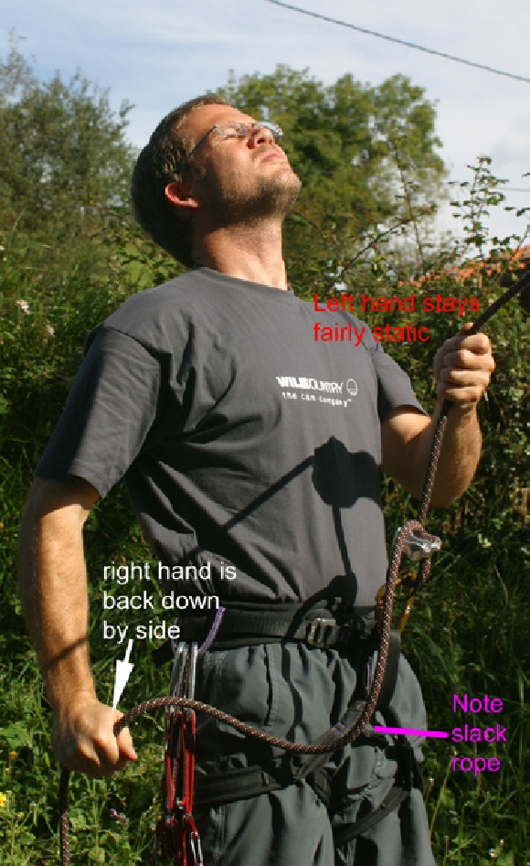

Essentially this picture sim-ply shows from another angle how the hands end up after the loop of slack has been pulled throught the device.

Note that unlike the original starting position there will be some slack between the Right

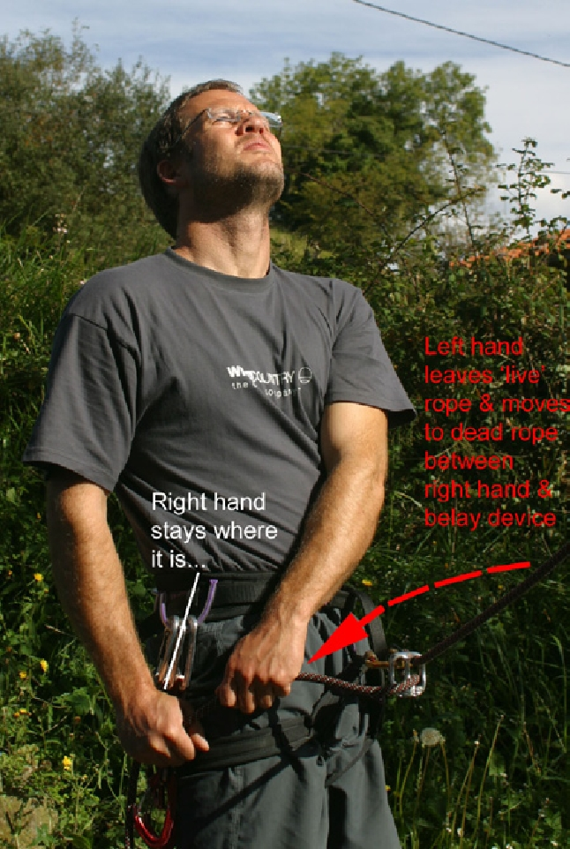

Hand and the belay device.

This is very important for step 6.

***Step 6***

Here the Left Hand becomes the key and moves from the live rope to very tightly grip the ‘dead’ rope just above where the right hand is holding it. At this point the Left Hand is in control of the rope.

Note: it is essential to leave a gap between the Left Hand and the belay device for step 7.

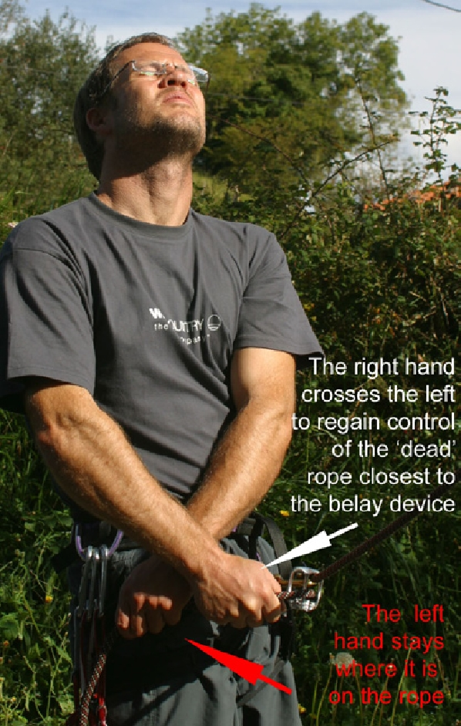

***Step 7***

Now the Right Hand crosses the

Left Hand and grips the rope closer to the belay device and takes full and sole control of the dead rope once again.

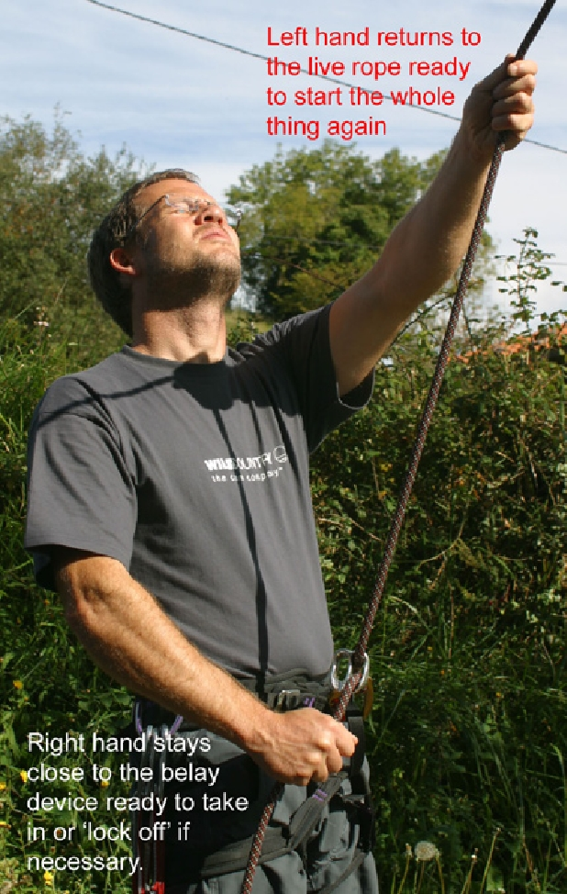

***Step 8***

The Left Hand is freed up and returns to the live rope exactly as it started and gets ready to feel for any slack. As soon as there is any slack the whole process starts again.

Some general hints:

1**. Never ever let go of the ‘dead’ rope - always keep at least one hand on it.**

1. Always try to watch the climber at all times - you can see if he is struggling or maybe if he is going to fall and prepare for that.
2. Practice, practice, practice, so that you can take in quickly and smoothly without taking your eyes off the climber.

Rock Climbing

Purpose of the lesson: Students know how the belay and can perform this safely with the help of a back-up student.

Students know how to wear a climbing harness (They did the prusik lesson a couple of weeks before the rock climbing.)

1. First you teach the first group of students (6 or 9) how to belay, because this is the most important aspect of the sport.
2. The first weeks we always use a back-up students who holds the dead end of the rope. So students work in a group of three.
3. If the first group is able to belay, they are going to teach a new group of 6 students. They have to explain the belaying and the commands. Of course you are responsible for the safety of the students, so the teacher pays attention if everything is all right.
4. Students can use the authentic material to see and read how the belaying works and they learn the words used in rock climbing.

**At a Glance:**  
**Before you climb:**

1. Is **your harness double backed**? At Driestar college we don’t have to do this anymore, because of new climbing harnesses.
2. Is the **climber's figure eight double backed** and does s/he have a **safety knot**?
3. Is your **partner's harness double backed**?
4. Is the **belay system secured** and is the carabiner locked?
5. Have you gone through the **starting commands**?  
   **Climber: "ON BELAY?"**     As in, "Am I on belay?"  
   **Belayer: "BELAY ON."**     The climber is secure in the belay system. The belayer is ready to brake any falls.  
   **Climber: "CLIMBING."**     This notifies the belayer that you have left the ground and your life is now in their hands.  
   **Belayer: "CLIMB ON." or "CLIMB AWAY."**     The belayer acknowledges the start of the climb.