Rainbow Jumper

EQUIPMENT: hula hoops (red, orange, yellow, green, blue, and purple), class list, pencil

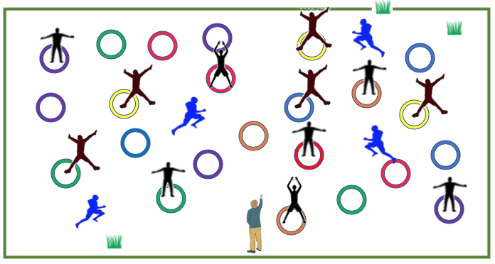

PLAYING AREA: field or gymnasium

- Spread out hula hoops on the field or in the gymnasium. Make sure you have at least three of each color.

- Assign four students to be “it”.

OBJECTIVE:

- The runners try to complete as many rainbow sequences as they can. To do this, they must do 10 jumps in each color of hoop, and they must complete their sequence in this order - red, orange, yellow, green, blue, purple.

RULES:

- The students who are “it” can interrupt a sequence by running a complete circle around someone who Is doing their jumps.

- If a runner’s sequence is interrupted, they must start again beginning with the red hula hoop.

- If a runner completes a rainbow sequence, they report it to the teacher and then repeat the process.

- Cheaters lose their points.

- The student with the most points at the end of each round wins. Each round is about 6 to 8 minutes. Runners should be changed after each round.

GAME VARIATIONS:

- Vary the number of hula hoops or runners.

- Change the movement pattern to walking, skipping, or galloping.

- Add a couple of multi-colored or different colored hoops that are “wild” and can represent any color.

- Have students earn team points rather than individual points. In this case, two of the people who are “it” would be on each team and would only target the other team.

Rainbow Jumper

